**we**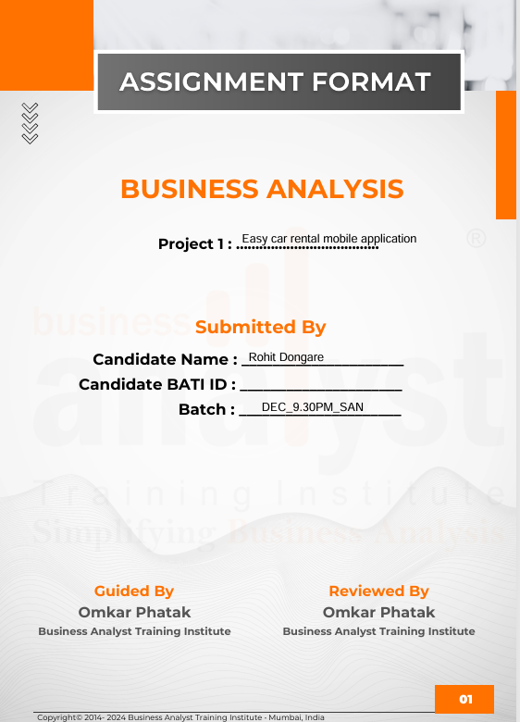

Contents

CHAPTER 1. IT COMPANIES 3

Departments of IT companies 3

Software Development Life Cycle (SDLC) & Business Analyst Role: 4

Project Initiation: 4

Requirement Gathering: 5

Development & Testing Phase: 6

Question answers of SDLC: 8

Chapter 2: Software Development Methods 28

Role of BA in scrum projects: 30

Agile ceremonies: 32

Chapter 3 – Business analyst role play 47

Sprint activities and meeting with the client: 47

Master table for city information: 51

Master table for car information: 51

Chapter 4-Unified Modelling Language (UML) 52

Chapter 5: Documentation 59

Business requirement document (BRD): 60

Software requirement specifications: 77

# CHAPTER 1. IT COMPANIES

**Business analyst:**

A business analyst is someone who mainly analyses, summarizes, and furnishes solutions to the business requirements of an organization and interprets the information based on various technologies and business processes by optimizing the overall cost.

IT companies are if two types:

1. B2C IT companies: Games, Windows
2. B2B IT companies: Online banking

**Introduction of IT companies**

An IT (Information Technology) company is a business that provides products or services related to computer hardware, software, networking, and other digital technologies.

There are two types of businesses:

1. B2B (Business to business)
2. B2C (Business to client)

IT companies can be divided into two categories:

**1) Product-Based IT companies:**

Product-based IT companies develop products according to requirements provided to them.

Examples of products are Mobile applications, web applications, etc.

**2) Service-based IT companies:**

Service-based IT companies provide services for products that have already been developed.

Services can be maintenance and support, testing, and digital marketing.

Departments of IT companies**:**

1. Departments of IT companies are as follows:
2. Software Development Department
3. Quality Assurance (QA) Department
4. Marketing Department
5. Human Resources (HR) Department
6. Data Analytics Department
7. Project Management Department
8. Technical Support Department

# Software Development Life Cycle (SDLC) & Business Analyst Role:

SDLC stands for software development life cycle.

It is a systematic process of software development that includes many phases. The phases of the SDLC are as follows.

1. Project Initiation
2. Project planning and resource allocation
3. Requirement Gathering
4. Development
5. Testing Phase
6. User acceptance testing (UAT)
7. Go-Live/Production
8. Maintenance & Support

# Project Initiation:

In this phase, the sales team and project manager are present for the meeting with the client. In this meeting, Sales and marketing take brief requirements from the client's side by showing them previous projects related to IT companies or a demo. Then, the Project Manager provides details of the budget to the Sales team, and the sales and marketing team take sign-off. In this phase, various documents are prepared, such as a gap analysis, proof of concept, SLA, demo, and project scope document.

**Role of BA in project initiation phase:**

Ba helps the project manager by doing a gap analysis, which helps him understand what features are missing in their existing product. Ba also helps the project manager prepare the project scope document and statement of scope of work. Ba also prepares a demo with UI screens. This is BA's role in the project initiation phase.

1. **Project planning and resource allocation:**

In this phase, the documentation of the team is prepared by the project manager, who are going to perform which task, how many members are there in Project share all this details with HR.

**Role of business analyst in project initiation phase:**

A business analyst is allocated for the project in this phase, and he will get project training.

In this phase, the project kick-off meeting is conducted, and the project manager will introduce his team to the client team, and the client will introduce his team to the project team.

# Requirement Gathering:

In this phase of SDLC project manager organize meeting with client in which they gathered collect information of existing business from clients and define solution to them at the end BA will make document of collected data which is called BRD (Business Requirement Document) & HLD (High Level Document) this process is High level requirement gathering. After this BA start meeting with SMEs (Subject Matter Expert) and convert all requirements technically and make documents which are TD LLD FRS FS SRS FRD VLS, etc.

**High level requirement gathering**

|  |  |
| --- | --- |
| **IT BA** | **Client team** |
| Arrange meeting RACI matrix is prepared. | Attend meeting |
| Send minutes of meeting |  |
| Send diagram of high level requirements of as is business process. | Approve or rectify minutes of meeting. |
| Arrange meeting to discuss high level flow of solution | Approve or rectify diagram |
| Send minutes of meeting. | Approve/ rectify minutes of meeting. |
| Prepare UI screen/ prototyping of high level | Approve and rectify. |
| Send BRD/HLD | BRD/HLD sign off. |

**Low level requirement gathering:**

|  |  |
| --- | --- |
| **IT BA** | **Client team** |
| Arrange meeting with SME’s RACI matrix is prepared. | Attend meeting |
| Send minutes of meeting |  |
| Send diagram of low level requirements of as is business process. | Approve or rectify minutes of meeting. |
| Arrange meeting to discuss low level flow of solution | Approve or rectify diagram |
| Send minutes of meeting. | Approve/ rectify minutes of meeting. |
|  |  |
| Prepare UI screen/ prototyping of high level | Approve and rectify. |
| Send SRS/FS/FRS/LLD/TD/FRD/FD | Technical document sign off. |

**Role of business analyst in requirement gathering phase:**

In this phase BA will gather requirement gathering BA will prepare RACI matrix.

High level requirement gathering:

BA will send minutes of meeting to the client. He will send high-level existing business process. He will arrange the meeting and the feasible flow of solution and prepared Business requirement document (BRD) and get approval.

Low-level requirement gathering:

BA will arrange the meeting with SME’s of client team as per RACI matrix and discuss existing business process on low level and send `s to the client for the same.

He will arrange the meeting and discuss the low level flow of the solution and send the FRD to the client and get approval.

# Development & Testing Phase:

In this phase of SDLC development team understand about the requirement that Client want after that team work on how to prepare the Application/website the Developer can also test his own code which is known as Unit Testing or White box Testing once the application or website is ready. They will give access to testing team.

Testing team tests the application/website with help of test cases they have prepared and approve them for UAT testing.

**Role of business analyst in development and testing phase:**

BA will help the development team to understand the requirements and ensure that the development aligns with business requirements.

BA helps in preparing test case documents for the testing team and ensures that the system meets business requirements through testing.

1. **UAT and Go-Live/Production:**

In this phase, the Testing team is ready to release the product on the UAT server. Then, they will test the product with the help of test cases given to them, or if they have a testing team, they test it using their own test cases, and it is ready to go for the go-live phase.

In the production phase, the actual user will use the application/website.

**Role of business analyst in UAT and go-live/production phase:**

If BA is from client side BA will understand the requirement from their business team and document the same. BA at the client side will be involved in the requirement gathering phase and convey all requirements to IT BA. He also verifies the technical documents prepared by IT BA. He prepared test case documents and was involved in UAT and production testing. Client BA will give sign-off on each UAT and production deployment.

BA role in third-party organisations:

Third party organisation can only involved in only testing, only development, only consulting or only maintenance and support. According to the services provided by third party organisation BA role differs.

In production phase BA ensures that the deployment aligns with business needs.

1. **Maintenance &Support:**

After the production phase, we are in the maintenance and support phase where any bug or change request can be taken.

**Role of business analyst in maintenance and support:**

This is the phase where BA is the only person in contact with the client. As per the Annual Maintenance Contract (AMC), BA’s Task is to take new requirements/changes/resolve issues.BA will do a feasibility check along with costing & send CR request to client. He will approve it, and phases of SDLC will be repeated.

# Question answers of SDLC:

1. **What is the role of BA in the project initiation phase?**

Ba helps the project manager by doing a gap analysis, which helps him understand what features are missing in their existing product. Ba also helps the project manager prepare the project scope document and statement of scope of work. Ba also prepares a demo with UI screens. This is BA's role in the project initiation phase.

1. **Is there any document BA prepares in the project initiation phase?**
2. Gap analysis b.
3. Project scope document
4. Proof of concept
5. SOW project scope document
6. Statement of scope of work.
7. **What are the artifacts of the project initiation phase?**
   1. Gap analysis b.
   2. Project scope document
   3. Proof of concept
   4. SOW project scope document
   5. Statement of scope of work
   6. SLA. (Service level agreement)
8. **What is the role of BA before allocating on a project?**

BA will be involved in the project initiation phase and BA will understand existing IT product by referring to previous documents. BA will also do a competitor application study so that he will get to know latest market features which he can suggest to client in future.

1. **What is the significance of product training given to BA?**

BA should know its own product so that he can resolve client queries in future. BA can also give client training and client wants to customize their product in the future BA can easily do first-level feasibility check and help his team to understand that customization.

1. **Can we skip high-level requirement gathering and go directly to low-level requirement gathering?**

Yes, sometimes to shrink the project timeline. The project manager asks BA to high level and low level requirement gathering together where BA gathers high level requirements from SMEs and also parallelly do low level requirement gathering. In such cases BA prepare only one document which includes all technical level details which may referred as BRD or FRD.

1. **Can we skip low-level requirement gathering and only do high-level requirement gathering?**

No, we cannot skip low-level requirement gathering. While high-level requirements provide a broad vision, low-level requirements define the specific details needed for implementation.

It ensures Clear and Precise Implementation, Supports Effective Testing and Validation, Helps in System Design and Development Hence low-level requirement gathering is important.

1. **What does a Business Analyst do in parallel to high-level AS-IS business process requirement gathering?**
2. BA will start preparing BRD.
3. BA will start discussing with clients' business teams on to be business process high level also BA will start meeting with client SMEs to understand as is business processes.
4. **How will you categorize change requests?**

Change request categorized in to below three areas:

1. Add a new feature
2. Change existing feature
3. Remove existing feature.
4. **What is the process to implement a change request?**

Every change request undergoes a change management process where IT organization maintains a form for every change request, also called a change request form (CR form).

CR form includes

1. Submitter information
2. Project manager feasibility check
3. Change control board (CCB approval)
4. Post approval Ba will do requirement gathering existing documentation and co-ordinate that change to relevant teams.
5. After this IT team will deliver that change to client on UAT and then production server.
6. After UAT and production sign-off. IT project team will review and close that change request.

1. **What decision BA will take if the client keeps changing requirements more frequently?**

BA will take all the suggestions from the client under the change management process. Where client will fill change request and submitter information. The project manager will review evaluate that change request. The change control board will approve the change. After receiving the approval BA will start requirement gathering for that specific change request.

1. **what will ba do if client's stakeholders are cancelling meeting frequently due to which you cannot achieve your given timelines for documentation?**

BA will understand the reason for cancellation and inform the point of contact BA was introduced in the project kick-off meeting and request him to allocate the other stakeholder.

BA will also report this to the project manager and if cancellation continues then BA will ask the project manager to escalate it to client's business team and extend the project timeline.

1. **Pre and post customization real life examples?**

Pre-customization is referred to customisation which will be done concerning gap analysis before developing the product.

Ex.

Missing features selected by the client. Additional features suggested by IT.

Post customization is referred as customization after delivering the product.

Ex.

Any customization post delivery where the client wants to add remove or change.

1. **what are the artifacts of the requirement-gathering phase?**
2. Meeting invites
3. Minutes of meeting
4. Diagrams of high-level and low-level UI screens
5. BRD
6. FRD
7. **What will be the role of BA if he doesn’t complete the documentation in the timeline given by project manager?**

BA has to report project manager related to project deliverables every day before he leaves for the day. The project manager will be aware of the reason or documentation delays. BA will ask the project manager for the technical help needed and a new updated timeline for documentation. This time BA should ensure documents will be delivered on time.

1. **is there any ba role in payment follow-up?**

No, Payment follow-up will be done by accounts team.

1. **Give real life examples of high medium and low severity bugs?**

High severity bugs: High impact on clients business. Because of this clients business may stop.

Issues in the payment.

OTP is not generated.

Medium severity bugs: Medium impact on clients business. Because of this clients business may not stop.

Ex. Bugs in the profile picture.

Low severity bugs:

Low impact of clients business. Because of this clients' business does not stop.

Ex.

Spelling mistakes.

1. **What is role of ba if there is any conflict while assigning priorities of bug, defect of issue between BA testing team and client?**

If it is bug the conflict will be resolved internally BA, development team and testing team. If it is defect or issue. BA will arrange meeting with clients team and explain them technical reason for assigning high, medium or low severity. BA will also understand clients business point of view for assigning high, medium or low severity. Post discussion both teams will conclude severity of defect or severity.

1. **what decision ba will take if UAT deployment is in next hour and tester and developer found high priority bug due to deployment cannot be carried out and client already pissed off due to previous delays?**

Ba will first coordinate with client and ask them that other than that specific bug try to test other features so BA will not release that part where bug is found and ask them to test other functionalities and within sometime BA will commit to submit that specific functionality which they hold due that bug.

1. **What is role ba if bug/defect/issue is taking more time to fix than the given timeline?**

BA will escalate this to the project manager and ask him to suggest how quickly they can fix that bug or issue. BA will also request to manager to provide expert development resource who can fix that bug or issue quickly to avoid the further delay.

1. **What is role of ba if client is taking more time for UAT deployment?**

BA will first check how much testing has been completed has been remaining. For example, seventy percent of testing is completed and thirty percent is remaining then BA will suggest not repair same thing which they have completed BA will also verify the client’s test cases and help them to complete UAT testing in time.

1. **Is it possible that there is one functionality that is not working on production environment but working perfectly on development, testing and UAT environment and if yes, how will developers fix it? What is the role of BA in this whole scenario?**

Yes, it is possible. One functionality is working on any one server that is not working on the other three servers because of data created in real-time. Ex. Developers have access to the development server they create; testers have access to testing servers and on the UAT server so the data is changing on various servers everyday. So we have to duplicate the data on which functionality is not working on the testing and development server it is called a recreation of the scenario.

1. **Do you share test case document with client after testing, describe your answer?**

It depends on the agreement between the two companies. If the client wants then we have to share the test case document with the client.

1. **Does client prepare Test case document?**

If the client has a testing team or if they have outsourced testing to any outside organization yes they do have a test case document.

1. **What is difference between internal deployment, UAT deployment and PRODUCTION Deployment?**

|  |  |  |
| --- | --- | --- |
| **Internal Deployment** | **User Acceptance Testing (UAT) Deployment** | **Production Deployment** |
| Developers deploy access to the testing server which is called internal deployment. | After internal testing, the code is moved to a UAT environment. Here, end-users or clients test the application to ensure it meets their requirements and expectations. | Once UAT is successful, the code is deployed to the production environment, making it live for all users. This stage requires careful planning to minimize downtime and ensure a smooth transition. |

1. **What is the role of BA in deployment process?**

BA does not play any role in internal deployment But there is involvement of BA in UAT and production deployment as follows.

BA will take release document from development team and convey same to client team and coordinate with client users and ask them to follow same steps on the day of deployment to make the deployment process smooth. BA will take assistance from developers and testers. BA will present on the day of deployment and monitor deployment process by taking remote desktop of client. If something goes wrong in deployment process BA will fix it with developers and testers. Post successful deployment BA will do sanity testing to make sure all features are working smoothly. BA will ask client users test the same and ask client users to give signoff on that specific deployment.

1. **What is the role of BA in the maintenance and support phase?**

Responsibilities of BA in the maintenance and support phase are as follows:

The BA receives and evaluates new requirements, changes, or enhancements from stakeholders. They conduct feasibility studies, assess the impact on existing systems, and prepare detailed change requests for approval. They assess and prioritize issues. collaborates with developers, testers, and support staff to implement solutions for identified issues or enhancements, ensuring that technical solutions align with business objectives. He ensures that all changes, fixes, and enhancements are thoroughly documented, maintaining an updated record of the system's evolution for future reference and compliance purposes. They work with support teams to monitor system performance, identify potential issues proactively, and ensure that the system continues to meet business requirements effectively.

1. **What is the BA role in each phase of SDLC?**

**Project Initiation Phase:**

**Role:** The BA assists in evaluating the feasibility of the project and understanding the business case.

**Activities:** Conducting cost-benefit analysis, identifying stakeholders, and helping in creating the project charter.

**Project Planning and Resource Allocation:**

**Role:** The BA collaborates in planning how the project will be executed and managed.

Activities: Eliciting and documenting requirements, creating use cases, and assisting in formulating project management plans.

**Requirement Gathering:**

**Role:** The BA leads the process of gathering and analyzing detailed business requirements.

Activities: Conducting interviews, workshops, and surveys; documenting and modeling requirements; and ensuring they are complete and feasible**.**

**Development:**

**Role:** The BA ensures that the development aligns with business requirements.

Activities: Clarifying requirements, addressing queries, and ensuring that development aligns with business objectives.

**Testing:**

**Role:** The BA ensures that the system meets business requirements through testing.

Activities: Assisting in defining test scenarios, validating the system against requirements, and collaborating with QA teams to ensure quality.

**User Acceptance:**

**Role:** The BA coordinates and conducts User Acceptance Testing (UAT) to validate that the solution meets business needs.

**Activities:** Facilitating UAT sessions, gathering feedback, and ensuring that the system is ready for deployment.

**Go Live/Production:**

**Role:** The BA ensures that the deployment aligns with business needs.

Activities: Coordinating deployment activities, ensuring that the system is rolled out smoothly, and assisting in user training and support**.**

**Maintenance Phase:**

**Role:** The BA ensures that the system continues to meet business needs post-deployment.

Activities: Managing change requests, prioritizing issues, coordinating with technical teams, and ensuring that the system remains aligned with business goals.

1. **What is the role of BA at client side and Role of BA in third party organizations?**

If BA is from client side BA will understand the requirement from their business team and document the same. BA at client side will be involved in requirement gathering phase and convey all requirements to IT BA. He also verifies the technical document prepared by IT BA. He prepared test case document and involved in UAT and production testing. Client BA will give sign off on each UAT and production deployment.

BA role in third party organisation:

Third party organisation can only involved in only testing, only development, only consulting or only maintenance and support. According to the services provided by third party organisation BA role differs.

1. **How project initiation phase will be different if there is no product exist with IT company?**

When IT company does not have any existing product their sales and presales team will do market research and also understands clients manual business. Post this they will prepare one demo for client which will be showcased to the client in the first meeting rest all procedures will be same in project initiation phase.

1. **What is the role of BA in GAP Analysis?**

In gap analysis, BA will understand what features a client wants in their existing product, what features clients don’t want in their existing features, what features they want to change in their existing features, and what features are missing in their existing features. After doing market research he will suggest some them some extra features If client wants to add.

1. **How BA will know which screens to be designed for POC?**

BA will refer project scope document and existing product of IT company to prepare proof of concept which will be demonstrated to client later.

1. **What is the role of BA if client make changes in POC again and again?**

After demonstrating proof of concept to client, BA will verify changes suggested by client with project scope document. If there is any feature or a change suggested by client leading to change in project scope BA will notify it to project manager and make the changes in proof of concept.

1. **How GAP analysis will be done if there is a product present with IT company?**

BA will demonstrate existing product of IT company to client. Post demo BA will understand what existing features client want and what existing features client wants to remove, what existing feature client wants to change. BA will also understand missing features in existing product by understanding clients existing business. BA will also do market research or competitive study suggest more features IT company can develop.

1. **What is RACI matrix? Is it coming throughout project or it changes time to time?**

This is a tabular representation of stakeholders involved in IT project from client side and IT side there are two RACI matrix prepared by BA First is IT RACI matrix and second is client RACI matrix.

RACI matrix changes throughout the project depending on stakeholder's availability.

**Responsible**: The individual(s) who perform the work to complete the task.

**Accountable:** The person who ensures the task is completed correctly and approves the work.

**Consulted:** Individuals who provide input and expertise during the task.

**Informed**: Stakeholders who need to be kept updated on progress and outcomes.

The RACI matrix is typically established at the beginning of a project to set clear expectations and communication channels.

1. **Who provides list of stakeholders in RACI matrix?**

The point of contact to whom BA get introduced in project kick off meeting.

1. **Why Requirement gathering will be done on High Level & Low Level?**

In high-level requirement gathering BA understands clients existing business which means departments and dependencies on each other. In sink with that BA prepares high level solution to be delivered to the client all will be documented in BRD which will be signed off by the client.

Post BRD sign off BA will understand client exiting process in detail. Client’s department experts as SME’s will give detailed understating of the department level processes including negative scenarios which will be further converted into technical document by business analyst with help of IT experts this technical document is referred as SRS, FRD, or low level document which is outcome of low level requirement gathering.

1. **How will BA gather requirements if there is no existing Business?**

BA will go through the basic needs and requirements of the client by going through the tender. BA will also do the market research and understand new features existing in the market since there is no as is business process BA will ask client to define the outline of to be process. Post understanding of to be business process (High level to be process) BA will start discussing to be process in detail (Low level to be process) with client SME and prepare documents. BA may suggest additional features which he understood after market research.

1. **What challenges BA face in requirement gathering?**
   * 1. Stakeholder availability
     2. Requirement changes
     3. Understanding the exact requirements of the client
     4. Communication gap
     5. If the client is not technically sound IT company may face challenges.
2. **How will client signoff or approve technical requirement if client is not technically sound?**

IT BA will explain technical requirements to the client. In some cases, client may hire consultants or business analysts to understand technical requirements and sign it off.

1. **What are types of Requirements?**

There are mainly two types of requirements.

1. Domain requirements (As is business process)
2. Technical requirements (To be business process)
3. Functional requirements
4. Non-Functional requirements.
5. **Which documentation BA prepares?**

Documents prepared by BA are as follows:

* 1. Business Requirement Documents
  2. Functional Requirement Specification (FRS)
  3. Non-Functional Requirement (NFR) Document
  4. Use Case Document
  5. Gap Analysis
  6. Change Request Document
  7. functional design.
  8. RACI matrix
  9. Requirement traceability matrix
  10. Minutes of meeting

Sometimes BA also prepares

* 1. Test case document
  2. Release document
  3. Database design

1. **Which documentation client Prepares?**
   1. Request for Proposal (RFP)
   2. Business Case
   3. Master Service Agreement
   4. User Feedback & Review Reports
   5. Compliance & Regulatory Guidelines
   6. Change Request Forms
2. **What is MOM? How to document MOM?**

After every meeting with the client BA will convey discussion points in detail to a client through email. The contents of the minutes of the meeting attendees from both companies their designations and attendance status.

Meeting agenda: Discussion points in the meeting and responsibility matrix (Table showing the responsibility of stakeholders and the due dates).

1. **How will you organize time if there are multiple projects assigned to you?**

In the case of multiple projects, BA has to organize time by prioritizing the projects according to their timelines. BA has also had to check and organize the project concerning stakeholders' availability on multiple projects. BA has to keep his calendar updated with all the appointments and agendas to be done. BA has to prepare project documents parallel to all other activities and he needs to take respective sign-offs in the given timelines.

1. **What is Version/ Release/ Build?**

**Version:**

When developers deploy a developed product from the development server to the testing server it is defined as version.

**Build:**

When they deploy from the testing server to the UAT server it is called build.

**Release:**

When they deploy from the UAT server to the production server it is called a release.

1. **What are different deployments?**

There are three basic deployments;

1. Internal Deployment
2. UAT deployment
3. Production or go live deployment.
4. **What challenges BA face in deployment?** 
   1. Last-Minute Requirement Changes
   2. Misalignment Between Business & Tech Teams
   3. Incomplete or Failed UAT (User Acceptance Testing)
   4. Data Migration & Integration Issues
   5. Stakeholder Resistance to Change
   6. Unexpected Production Issues (Post-Deployment Bugs)
   7. Communication Gaps Between Teams
   8. Performance & Scalability Issues
   9. Compliance & Security Risks
5. **What is a stakeholder?**

The person involved in a project from the IT or client side, who can change the requirement directly or indirectly is defined as a stakeholder.

1. **How BA performs testing?**

BA is involved in testing of each version built and released which is called functional testing or black box testing. BA will also do high-level testing of each version or build. BA will also do smoke testing which done on successful deployment of the UAT server and production server.

1. **How BA resolve conflicts between client's requirement changes & IT technical team?**

Requirement changes will lead to rework for the technical team such as UI designers development team and testing team. BA has meetings with the technical team and the project manager explains the requirement changes to the team in meetings. BA also explains reasons for requirement changes frequently and approvals given by project manager on those changes.

1. **When can you expect Requirement changes more? How will you handle it?**

Requirement changes will expected in the project initiation phase, requirement gathering phase, UAT testing and maintenance and support. BA will handle all requirement changes through change management process we have seen previously by taking formal approvals from client project manager and change control board by filling change request form.

1. **Give Real life ex. for B2B Client. - i) Software ii) Mobile Application iii) Website and Web Application**
2. **B2B Software Example**

Scenario: A Software company providing Enterprise Resource Planning (ERP) systems to a manufacturing business.

Client’s Initial Requirements:

The manufacturing company requests an ERP system to handle inventory, employee management, and order processing. Initially, the client wants the software to work with basic data like product codes, quantity, and employee hours.

Change Request:

Midway through the development, the client asks for advanced features, like real-time tracking of inventory, integration with external suppliers' systems, and support for mobile devices.

They also request a customizable dashboard for different departments (sales, finance, HR).

How the BA Handles It:

Impact Analysis:

The BA evaluates the technical feasibility of integrating real-time inventory and external systems with the ERP. They also assess the cost and timeline for adding mobile support and custom dashboards.

Change Request Documentation:

The BA documents the new requirements and their impact on the project scope, timeline, and budget. The client must approve these changes formally.

Stakeholder Communication:

The BA facilitates meetings with the client and the IT team to understand the priorities (real-time tracking might be more critical than mobile support) and to come to a compromise.

Negotiation & Prioritization:

The BA works with the client to prioritize the changes. They propose an incremental approach:

Phase 1: Implement inventory tracking and supplier integration.

Phase 2: Add mobile compatibility and dashboard customization.

**ii) B2B Mobile Application Example**

Scenario: A mobile application development company providing a business analytics app to a sales organization.

Client’s Initial Requirements:

The sales organization wants a mobile app that provides sales performance analytics, including key metrics like sales volume, revenue, and customer acquisition trends.

Change Request:

During testing, the client requests real-time updates for sales figures, geolocation tracking for field agents, and push notifications for target achievement alerts.

How the BA Handles It:

Requirement Clarification:

The BA schedules a meeting with the client to clarify their exact needs. They confirm the specifics of real-time data, location tracking, and the push notification triggers (e.g., based on specific sales goals).

Feasibility Check:

The BA works with the technical team to assess the feasibility of real-time synchronization with the existing sales management system and the integration of geolocation APIs.

Scope Adjustment:

The BA and client agree to prioritize:

Phase 1: Real-time updates and performance metrics.

Phase 2: Geolocation and push notifications (can be implemented after initial deployment).

Cost and Time Estimates:

The BA ensures that the estimated cost and timeline for these changes are updated, and the client signs off on the revised scope.

**iii) B2B Website and Web Application Example**

Scenario: A web development agency building a customer portal for a wholesale distributor.

Client’s Initial Requirements:

The wholesale distributor wants a self-service portal for its customers to place orders, check order history, and manage deliveries.

Change Request:

Midway through the project, the client requests to integrate live chat support, a payment gateway, and multi-language support for international customers.

They also ask for a customized reporting dashboard for their internal team to track customer behavior and sales patterns.

How the BA Handles It:

Gathering Detailed Requirements:

The BA collects detailed information on the new features requested, ensuring they are aligned with the client’s business goals (e.g., increasing customer satisfaction with live chat support).

Technical Evaluation:

The BA works closely with the development team to assess the feasibility of integrating a payment gateway and live chat while ensuring that the website can handle multi-language content.

Documenting the Changes:

The BA formalizes the changes in a Change Request document that outlines the scope, timeline, and budget revisions. The changes are reviewed by the client and signed off before proceeding.

Prioritization and Timeline Adjustment:

Given the complexity of the changes, the BA collaborates with the client to:

Phase 1: Launch the core portal functionality (order placement, order history, delivery tracking).

Phase 2: Implement live chat, payment gateway, and multi-language support in subsequent updates.

Testing and User Acceptance:

As part of testing, the BA ensures the new features are properly tested in the development environment and conducts a User Acceptance Testing (UAT) session to verify that the portal meets the updated requirements.

1. **Give Real life ex. for B2B Client. - i) Add Feature ii) Remove Existing Feature iii) Change Existing Feature.**
2. **Add Feature**

**Scenario:** A CRM Software Company (e.g., Salesforce) receives a request from a B2B client (a bank) to add an AI-powered chatbot to automate customer interactions.

**Client Request:**

"We need an AI-powered chatbot in our CRM to handle common customer queries before directing them to human agents."

**BA’s Role:**

Gather requirements (types of queries, AI capabilities, integrations).

Work with developers to design the feature.

Conduct User Acceptance Testing (UAT) before rollout.

**Outcome:**

A new AI chatbot is added to the CRM, improving customer service efficiency.

**Remove an Existing Feature**

**Scenario:** A SaaS-based HR Payroll Software provider (e.g., Workday) receives feedback from a B2B client (a multinational corporation) that the email notifications for minor payroll changes are unnecessary and causing email overload.

**Client Request:**

"Please remove automatic email alerts for every payroll update, as employees are getting too many emails."

**BA’s Role:**

Analyze the impact of removing the feature.

Get approvals from stakeholders.

Update documentation & notify users before removal.

**Outcome:**

The email notification feature is removed, reducing unnecessary communication clutter.

**Modify an Existing Feature**

**Scenario:** A B2B e-commerce platform (e.g., Shopify Plus) has an order tracking feature where clients (wholesalers) can track shipments. A retail client requests an enhanced tracking system that includes real-time GPS tracking and estimated delivery time updates.

**Client Request:**

"We need more detailed order tracking with real-time GPS updates for better logistics visibility."

**BA’s Role:**

Identify required changes in the existing feature.

Work with IT & logistics teams for GPS integration.

Ensure smooth transition without disrupting current users.

**Outcome:**

The existing order tracking feature is improved, adding real-time GPS tracking and estimated delivery times.

1. **Explain the business model of IT companies.**
   1. **Service-Based Business Model (IT Services)**

These IT companies provide custom software development, consulting, maintenance, and IT solutions to businesses. Their main focus is offering outsourcing services for software, cloud computing, infrastructure management, and digital transformation.

**Example**: TCS, Infosys, Accenture, Wipro

* 1. **Product-Based Business Model (Software Products)**

These companies develop software products (SaaS, enterprise solutions, consumer software) and sell them to customers. Instead of offering services, they focus on developing a scalable product that can be sold to multiple businesses.

Example: Microsoft, Adobe, Salesforce, SAP

* 1. **IT Consulting Business Model**

IT consulting firms provide strategic guidance to businesses on technology adoption, IT transformation, cybersecurity, and cloud solutions.

**Example**: Deloitte, McKinsey Digital, Capgemini

1. **Explain the BA Role in IT and client company.** 
   1. **BA Role in an IT Company**

In an IT company, the BA primarily works as part of a software development team, ensuring that client requirements are well-documented and implemented correctly.

**Requirement Gathering** – Understand and document the client’s needs for the IT team.

**Business Process Analysis** – Analyse existing workflows and suggest improvements.

**Requirement Documentation** – Prepare BRD (Business Requirement Document) and SRS (Software Requirement Specification).

**Liaison Between Stakeholders** – Act as a bridge between business users and IT teams.

**Change Management** – Handle requirement changes and assess their impact on the project.  
**User Acceptance Testing (UAT)** – Ensure the final product meets business expectations.  
**Project Coordination** – Work with project managers, developers, and testers to ensure smooth project execution.

* 1. **BA Role in a Client Company (End-User Organization)**

In a client company, the BA ensures that internal IT solutions align with business goals and improve operations.

**Understand Business Needs** – Work closely with department heads to identify IT requirements.  
**Evaluate IT Solutions** – Assess whether to buy a software product or develop a custom solution. **Vendor Coordination** – Work with external IT vendors to implement solutions.  
**Process Improvement** – Optimize internal workflows using IT solutions.  
**Training & Support** – Help business users adopt new IT systems effectively.  
**Post-Implementation Review** – Monitor system performance and gather user feedback.

1. **BA should have domain knowledge**

True

1. **BA is allocated in more than one project**

True

1. **BA can work in different domains**

True

1. **Explain Product based and service based IT companies.**
   1. **Product-Based Business Model (Software Products)**

These companies develop software products (SaaS, enterprise solutions, consumer software) and sell them to customers. Instead of offering services, they focus on developing a scalable product that can be sold to multiple businesses.

Example: Microsoft, Adobe, Salesforce, SAP

* 1. **Service-Based Business Model (IT Services)**

These IT companies provide custom software development, consulting, maintenance, and IT solutions to businesses. Their main focus is offering outsourcing services for software, cloud computing, infrastructure management, and digital transformation.

**Example**: TCS, Infosys, Accenture, Wipro

1. **Give Real life examples of B2B and B2C products.**

**B2B:**

**Tableau (Data Visualization Tool) –** Used by businesses for analytics and reporting.

**Snowflake (Cloud Data Platform) –** Helps enterprises store and process large data sets.

**IBM Watson (AI & Machine Learning Platform)** – Used by businesses for AI-driven insights.

**B2C**

**Google –** Provides B2C products like Google Search, Gmail, Google Maps, YouTube, Google Drive.

**Microsoft** – Offers B2C products like Windows OS, Microsoft 365 (Word, Excel, PowerPoint), OneDrive.

1. **Explain Different project types by giving one example of each**

**Software Development Projects**

These projects involve designing, developing, testing, and deploying software applications.

**Example:** Microsoft Office Suite – A software project that includes applications like Word, Excel, and PowerPoint, developed for productivity.

**Website Development Projects**

These projects focus on designing and developing websites for businesses, individuals, or organizations.

**Example:** Amazon.com – E-commerce website that allows users to browse and buy products online.

**Mobile Application Development Projects**

These projects involve creating mobile applications for Android and iOS platforms.

**Example:** WhatsApp – A messaging app that allows users to send messages, make calls, and share media.

**Cloud Computing Projects**

These projects involve migrating systems, data, and applications to cloud platforms.

**Example:** Google Drive – A cloud storage platform that enables users to store and access files online.

**Cybersecurity Projects**

These projects involve improving security measures to protect systems and data from cyber threats.

**Example:** Norton Antivirus – A cybersecurity software that detects and removes viruses and malware.

1. **What do you mean by Customized products?**

Customized products refer to software or IT solutions that are tailored specifically to meet the unique requirements of a business or user. Unlike off-the-shelf products, which offer standard features for a broad audience, customized products are designed and developed based on specific business processes, workflows, or individual preferences.

1. **Name one product-based and service-based IT company.**

**Product-Based IT Company:** Microsoft

**Service-Based IT Company:** Tata Consultancy Services

1. **Which application will IT company sell for Newspaper agency, Dairy shop, fashion designing firm.**

**Newspaper Agency:** Digital Publishing & Subscription Management System

**Dairy Shop:** Dairy Management & POS System

**Fashion Designing Firm:** Fashion Design Software & E-Commerce Store

1. **Explain IT departments.**

**IT Infrastructure & Networking**

Manages hardware, servers, networks, and cloud infrastructure.

Network setup & maintenance (LAN, WAN, Wi-Fi)

Server & database management

Cloud computing (AWS, Azure, GCP)

IT hardware (laptops, printers, routers

**Software Development & Engineering**

Designs, develops, tests, and maintains applications.

Custom software & web development

API & database integration

Mobile app development (Android, iOS)

**Example:** Microsoft developing Windows & Office 365.

**IT Support & Helpdesk**

Provides technical assistance to employees and customers.

**Key Responsibilities:**

Troubleshooting hardware/software issues

Resolving system & network errors

User account management & access control

IT training for employees

**Example:** A company’s IT helpdesk solving employee login issues.

**Database Management**

Manages company data and enables data-driven decision-making.

**IT Project Management**

Manages IT projects, timelines, and cross-team collaboration.

1. **How project team is different in MNCs and Small IT organizations.**

In multinational corporations (MNCs), project teams are typically large and structured, with clearly defined roles such as project managers, business analysts, software architects, developers, testers, and DevOps engineers. These teams follow well-established methodologies like Agile, Scrum, or Waterfall, with multiple layers of approvals and strict compliance requirements. Due to the size of the organization, decision-making is often slower as it involves multiple stakeholders. MNCs have access to high budgets, enterprise-level tools, and standardized technology stacks, making their approach more process-driven and documentation-heavy. Client interactions are usually managed by dedicated business analysts or account managers, keeping the development team focused on technical execution.

In contrast, project teams in small IT organizations are much leaner, with individuals often taking on multiple roles. A developer might also handle testing, while a project manager may double as a business analyst. These teams operate in a more flexible and dynamic environment, making quick decisions without going through multiple approval layers. Since resources and budgets are limited, small IT firms prioritize cost-effective tools and rapid development methodologies like Lean or Agile. Client communication is more direct, with developers and project managers frequently interacting with stakeholders to understand and implement requirements quickly. Documentation is minimal, focusing more on execution and adaptability rather than rigid processes.

Overall, while MNCs prioritize stability, scalability, and structured workflows, small IT organizations emphasize speed, flexibility, and innovation. Both models have their own advantages, with MNCs excelling in large-scale, long-term projects requiring high compliance, and small IT firms being more suited for fast-paced, iterative development with a focus on quick market entry.

1. **what is company billing and client billing, which one is better.**
   1. **Company billing:**

Employees are on the company's payroll, and their salaries are paid by the company regardless of whether they are assigned to a client project or not. The company takes responsibility for managing resource allocation and absorbs costs when employees are on the bench (not assigned to a project).

* 1. **Client Billing**

In Client Billing, employees are billed directly to the client based on project work. The company charges the client based on hourly/daily/monthly rates for each employee working on the project. If an employee is not assigned to a client project, they may not generate revenue for the company.

Client Billing is generally better for the company's profitability since it ensures that every resource assigned to a project directly generates revenue. However, it creates job uncertainty for employees if they are frequently on the bench.

1. **How many BA are allocated in one project, justify your answer**

The number of Business Analysts (BAs) allocated to a project depends on various factors such as project size, complexity, industry domain, and organizational structure.

While a small project may only require one BA, larger or more complex projects need multiple BAs to efficiently gather and manage requirements, ensuring smooth execution and stakeholder alignment.

# Chapter 2: Software Development Methods

Different Software development methods exist because there are different clients in the past in 1960 after the Programming EXP Source of internet came and development started like web applications, Mobile applications, Websites, etc. Companies across world work on various Operating systems and devices. Requirements from client changes time to time therefore these are all trends in IT industry getting upgrade day-by-day and give the perfect solution to client with latest Software Development Method.

We will be going to see two software development methods:

1. Waterfall
2. Agile scrum
3. **Waterfall:**

The waterfall method is also known as the top-down approach/ sequential/ traditional method. This method is implemented when we have clear requirements. The waterfall name suggests that the waterfall flows from top to down; it means once u go to a new phase in the waterfall model it can’t be repeated. You can’t go back to the previous phase due to this is the reason it has a top-down approach. There is no chance to make any change in this model. This method is also known as the sequential method.

1. Project Initiation: -

2. Planning and resources allocation

3. Requirement Gathering

4. Development & Testing

5. UAT

6. GO Live Production

7. Maintenance & Support

**Role of business analyst in the waterfall method:**

BA will arrange the meeting with client and will gather requirements for each waterfall models. BA will do detailed documentation, sign off after testing, And if change requests are urgent, he will run a parallel waterfall and that is waterfall 2, where BA will gather requirements and he will also work on deliverables of waterfall one. IE example BA will work on waterfall one and also on parallel waterfall two.

**Advantages and disadvantages of the waterfall method:**

|  |  |
| --- | --- |
| **Advantages** | **Disadvantages** |
| 1. Timeline and cost are fixed. | 1. Client can’t implement changes anytime they want |
| 1. Quality of the product is good because there is no impact of change in waterfall. | 1. Client has to wait longer for the deliveries |
| 1. Documentation is always detailed. | 1. There is no clear visibility of the product to the client before UA |
| 1. Easy to track the progress. | 1. Testing occurs at the end of the process, which can result in discovering critical issues too late. |
| 1. Each phase has specific deliverables and a review process, ensuring clear project milestones. | 1. Clients typically see the final product only after completion, which can lead to misalignment with their expectations. |

1. **Agile-Scrum:**

This method is generally used in projects that have unclear requirements.

**Agile:**

The Dictionary meaning of agile is rapid or fast. It means in this model delivery of product is done very rapid and fast. This project is used when there are unclear requirements from client and hyper-changing requirements, as well as Complex projects.

**Scrum:**

The word Scrum came from the game American football rugby. Where teams gather, first they plan & execute. In a scrum project, there is a scrum team in which the Product Owner, Scrum Master, & Cross-functional teams such as Developers & Testers work together.

In this method, after requirement gathering, BA converts requirements into user stories and creates a product backlog. He conveys user stories to scrum master and cross functional teams.

Cross-functional teams start developing features/user stories according to the sprint backlog. While developing these feature, they will follow an iterative approach, i.e.

* + - * 1. Plan
        2. Design
        3. Develop
        4. Test
        5. Deploy

# Role of BA in scrum projects:

If BA is experienced, then he is hired as a product owner. He will collect requirements, create user stories, prepare product backlogs, prepare Sprint backlogs, give a product update to the client, and participate in Sprint ceremonies.

If BA is from a technical background, he can work as scrum master and resolve technical issues queries of cross functional teams, monitor and guide them.

He can be hired as BA and work along with the product owner and scrum master.

Deliverables:

Collect requirements

User stories

Product backlog

Sprint backlog

Product updates to clients participated sprint ceremonies.

He will resolve technical issues. BA is involved in testing as well.

|  |  |  |  |  |  |
| --- | --- | --- | --- | --- | --- |
| **Sr.**  **number** | **Meeting** | **Attendees** | **Duration** | **Points to discuss** | **When to commence** |
|  | **Daily standup meeting** | Scrum team and client (Optional) | 15 min to 30 min | what we have done yesterday, what is the plan today and what challenges we face, what challenges we face yesterday. | Starts in morning or evening every day. |
|  | **Sprint planning meeting** | Scrum team | One to two hours depending upon the user stories and the point that is discussed is Sprint backlog and sprint estimation. | Previous sprint task and planning of next sprint task | Starting of sprint |
|  | **Sprint review meeting** | Scrum team and client. | one to two hours depending upon the user stories and the next point to be discussed. | demonstration user stories to client.  In each Sprint and collect the feedback from client. | when to start at the end of each Sprint. |
|  | **Sprint retrospective meeting** | Scrum team. | when to start at the end of each Sprint. | Any achievements and drawbacks are discussed | End of sprint |

# 

# Agile ceremonies:

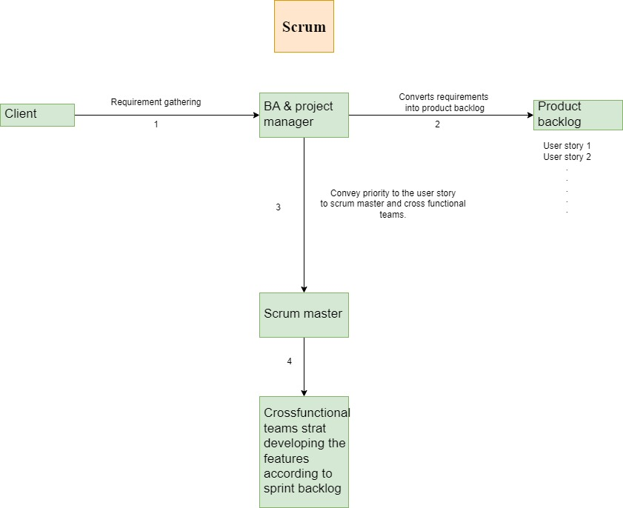

Waterfall and agile questions and answers

1. **Give two real-time example of the below type of projects** 
   1. **Project with clear requirements**

a. Banking application

b. Adhar card website

* 1. **Project with unclear requirements**

1. Food Delivery application (Swiggy)
2. E-commerce website (Amazon)
   1. **Complex project**
3. Blink it
4. Amazon
   1. **Customization project**

a. WhatsApp update

b. Snapchat update

1. **Give three different real life examples in three different domains where you implement the waterfall method?** 
   1. Banking application
   2. Adhar card website
   3. Retail shop application
   4. Real estate
   5. Ticket booking
   6. Automobile
2. **How to overcome the disadvantages of the waterfall model?**

while define the software develop development methodology IT project team will verify. That if this client is best for waterfall implementation where they verify below.

* 1. client requirements should be clear.
  2. client can wait longer for deliveries.
  3. project is not complex and if the client is not in above methods then software company will implement different software method.

1. **What is the role of BA in waterfall models 1,2 and parallel waterfall models we have seen so far?**

BA will arrange the meeting with client and will gather requirements for each waterfall models. BA will do detailed documentation, sign off after testing, And if change requests are urgent, he will run a parallel waterfall and that is waterfall 2, where BA will gather requirements and he will also work on deliverables of waterfall one. IE example BA will work on waterfall one and also on parallel waterfall two.

1. **How do maintenance & support work in the waterfall model & what is the role of BA in the same?**

As per AMC annual maintenance contract, BA will take new requirements, changes, enhancements or resolve issues. Feasibility check and costing will be done. And BA will send CR which is change request or change requirements form to client. So change request and change requirements form to client will be sent by BA. Client will approve CR form which is change request form and the phases from the development to live to life will be repeated.

1. **Does passport seva website built using a waterfall model, if yes justify the answer**

No because complex projects will never implement through waterfall. Because every requirement in this project is impacting more than 99% of functionalities of REST project or the other projects.

**Agile questions**

1. **What is the role of BA in SCRUM project? What are the deliveries are they expecting from BA in SCRUM projects?**

If BA is experienced, then he is hired as product owner. He will collect requirements, create user stories, prepare product backlogs, prepare Sprint backlogs and give a product update to client and participate in Sprint ceremonies.

If BA is from technical background he can work as scrum master and resolve technical issues queries of cross functional teams, monitor and guide them.

He can be hired as BA and work along with product owner and scrum master.

Deliverables:

Collect requirements

User stories

Product backlog

Sprint backlog

Product updates to clients participated sprint ceremonies.

He will resolve technical issues. BA is involved in testing as well.

1. **How documentation will be prepared in SCRUM projects?**

For user stories, use case specification documents will be prepared for all agile projects. For application development project you will find BRD technical documentations in terms of use case specifications. for customization project there will be no BRDS. There will be only use case specification documents

1. **How costings and timelines decided in SCRUM projects?**

Costing will be done by discussing with the client where product owner discuss with client and costing is also done with respect to the user story.

Another timeline for that is first by asking the client when and which user stories they want on a particular sprint.

IT team may take all user stories on sprint at once and decide the timeline. They may take five by user stories on sprint and decide the timeline. They may also take one user stories on one sprint one by one, decide and decide the timeline.

1. **What is the role of BA in SCRUM project? What are the deliveries are they expecting from BA in SCRUM projects?**

BAs play a crucial role in bridging the gap between business and technical teams. Their responsibilities can vary depending on the project's needs and team structure.

Role of BA in scrum project:

1. Requirement gathering and documentation
2. Product backlog management
3. Helping developing team and testing team
4. Communicating with stakeholders
5. Participate in Sprint Planning, Daily Stand-ups, Sprint Reviews, and Retrospectives

**Deliveries by BA**

* 1. BRD
  2. FRD
  3. Product backlog refinement
  4. Test case review and support
  5. Minutes of meeting
  6. Process flow diagrams
  7. Wireframes

1. **Who will BA reporting too in SCRUM project?**

BA will report to scrum master and product owner as a scrum master.

A scrum master he will report to product owner and as a product owner, a product owner will report to head product owner.

1. **What is the role of project team in SCRUM project?**

Role of project team As for business analyst BA. With the product owner will gather requirements from client and will convert requirements into user stories and will help to create product backlog. BA with product owner will convey priority user stories to scrum master. BA will go in Sprint meeting to know what and when the client wants. BA will also make a documentation of product backlog and Sprint backlog.

Product owner is responsible to take responsibility of the entire project and to deal with the success and failure of the project. He also monitors the team progress and coordinates with clients.

Scrum master. He is the technical head who checks the technical glitches and helps cross-functional team and client.

Cross-functional team. They are engaged in incremental delivery and iterative approach of plan. Design, develop, test and deploy.

1. **Is there development, testing, UAT and production server existing in SCRUM project?**

Yes, there is development testing UAT and production server existing in Scrum project no matter what software development methods used. There all the servers mentioned are always present as they have all the servers.

1. **What is the role of BA in deployment process in SCRUM project?**

BA will take the release document from the development team and convey the same to client users. BA will ask client users to follow the same step mentioned in release document on the day of deployment BA will take assistance from development and testing team.

BA will monitor deployment process by taking remote desktop of client users for smooth deployment. If something goes wrong in deployment process, BA will ask developers and testers to fix it. After successful deployment, BA will do sanity testing to make sure all high level functionalities are working fine. BA will also ask client users to test the same and give sign off on specific deployment.

1. **Which tool they use to maintain product backlog and sprint backlog in AGILE SCRUM?**

It differs from company to company that which tool to use To maintain product backlog following tools are used:

1. Jira
2. Azure DevOps
3. Trello
4. ClickUp
5. Monday.com
6. Excel and Jira is one of the tools followed by Zepel ZEPEL Erlo, which is EREELO, Zoho Sprint, ZOHOSPRIND.
7. Ntask, which is NPASK and.
8. Microsoft Planner and VV5, which is VIVIFY, Scrum, etcetera, VV5, Scrum and etcetera
9. **Is Sprint timeline are pre-decided or decided on the go?**

Sprint timelines are decided according to the clients. But asking the client when and which user stories they want in particular Sprint first one Sprint at a time. that's an approach.

One first Sprint completes, they take the next Sprint.

Then the second second thing is they may take all Sprint at once and decide the timeline.

And the third way is they may take 5 sprints in one.

1. **Who is the decision maker to decide which user stories to be taken in specific Sprint?**

Client is the decision maker to decide which user stories to be taken in specific Sprint and also in IT team. So IT team will consult with the client which user stories should be taken in specific sprints.

1. **Do they have SCRUM team at client side? If YES explain the role of each team member?**

There might have a scrum team at client side, be a product, be a product owner, scrum master and cross-functional team. There can be testing team and support team as well.

Next is BA from client team. So BA will approve the documents which will be given by the IT company. He will also go in Sprint meetings. Second is product owner from client team.

He will convey the requirements of project to the IT team and will keep the updates of project. Third is scrum master from clients team he Will monitor team if he's the technical scrum master. He will also take updates from clients cross-functional team about the product and he will resolve the problems of his which is client side team

1. **What is iterative approach and incremental delivery?**

Each Sprint backlog is deployed independently and in incremental delivery.

The new Sprint backlog will be delivered along with previously tested one

for example, in iterative approach, user stories are delivered in iteration.

there is iteration one.

This is a pictorial explanation.

iteration 1, iteration 2 and iteration 3 and there is there is five.

There is five process.

First is plan, second is design, third is develop, 4th is test and 5th is deploy.

And this is the same for all the three iteration this process.

Sprint one there is version 1.0 which is homepage.

Sprint 2 version 1.1 registration, Sprint 3 version 1.2 login and Sprint 4 version 1.3 selected.

Now incremental delivery delivery increments after every Sprint as shown below.

This is Sprint one version 1.0 with that homepage.

Sprint 2 version 1.1 homepage plus registration

Sprint 3 version 1.2 homepage plus registration plus login.

Sprint 4 version 1.3 homepage plus registration plus login plus selective.

1. **Who has the rights to stop specific sprint?**

Product owner has rights to stop the specific sprint if client doesn’t want. The specific user story then client can convey to product manager to stop that specific sprint.

1. **Will you find SCRUM team at one location or different location?**

We can find scrum team at one location because each IT team requires requirement can be.

From the one office itself and also scrum team can be at different location because scrum team that IT company requires can be hired from different office or from out of Mumbai or from out of country foreign countries.

1. **Advantages and Disadvantages of SCRUM?**

**Advantages of scrum:**

1. Faster Delivery & Continuous Feedback.
2. It is flexible and adaptable.
3. Better product quality.
4. Risk mitigation
5. Scrum is used for complex projects.
6. clear visibility of project to client.
7. project delivery is rapid and fast.
8. product quality is better.

**Disadvantages of SCRUM**

1. It requires experienced teams
2. Difficult to Predict Cost & Timeline
3. Constant change requests can lead making it hard to finalize the product.
4. Documentation is not done in detail.
5. Sometimes requirements may rapidly change.
6. Skilled resources are required.
7. Lack of coordination in teams due to distributed approach.
8. **What is the maximum size of SCRUM team?**

Excluding product owner Scrum Master BA, the maximum size of Scrum team is 9, which include developer, tester, database design, UI designer.

1. **What is sprint task board?**

It's the visual display of progress of Scrum team during a Sprint. It represents a snapshot of current Sprint backlog, allowing everyone to see which task remain to be started, which are in progress and which are done. Sprint Task Board is for IT team and not for flight.

1. **Explain AGILE ceremonies in below format**

|  |  |  |  |  |  |
| --- | --- | --- | --- | --- | --- |
| **Sr.**  **number** | **Meeting** | **Attendees** | **Duration** | **Points to discuss** | **When to commence** |
|  | **Daily standup meeting** | Scrum team and client (Optional) | 15 min to 30 min | what we have done yesterday, what is the plan today and what challenges we face, what challenges we face yesterday. | Starts in morning or evening every day. |
|  | **Sprint planning meeting** | Scrum team | One to two hours depending upon the user stories and the point that is discussed is Sprint backlog and sprint estimation. | Previous sprint task and planning of next sprint task | Starting of sprint |
|  | **Sprint review meeting** | Scrum team and client. | one to two hours depending upon the user stories and the next point to be discussed. | demonstration user stories to client.  In each Sprint and collect the feedback from client. | when to start at the end of each Sprint. |
|  | **Sprint retrospective meeting** | Scrum team. | when to start at the end of each Sprint. | Any achievements and drawbacks are discussed | End of sprint |

1. **What is sprint burn down chart?**

A Sprint Burndown Chart is a visual representation of work completed vs. work remaining in a Sprint.

1. **What is sprint burn up chart?**

Burn up chart is used to track how many users stories have been completed and the completed work and total work is shown on the vertical axis in whatever units a project team feels works best.

Example work hours, work days, story points or any other work unit.

So you can see the horizontal axis displays time usually in days, weeks or iteration which is sprints.

1. **What are story point?**

Story point is a metric used in agile to estimate the difficulty slash complexity of given user story. Difficulty could be an abstract measure of complexities, risks and efforts involved.

Different methods in different companies calculate it.

Fibonacci series example 1, 2, 3, 5, 8, 13, 21….and is it goes on.

So that is one such method to calculate story points.

So there is one to two will be low complex, 358 will be medium complex and.

13 and above will be high complex 13 to 21.

1. **What is velocity?**

Velocity is a measure of amount of work a team can tackle during a single Sprint and is the key metric in Scrum.

Velocity is calculated at the end of the Sprint by summing up the points for all fully completed user stories.

1. **What is poker planning?**

Poker planning, also known as Scrum poker, is a consensus based gamified technique for estimating efforts involved according to development size or goal of the project.

Story points are set in poker planning.

In other words, poker planning is a method used to calculate the amount of user stories one should take as a target for a given Sprint based on their story points or complexity.

Here there is a pictorial explanation of poker planning.

One is registered, so 1-2 is low, 358 is medium and the high is 13 to 21.

So in this the 1st.

In this the 1st is PO.

So what is PO is PO is product owner.

Then that comes in the first which is date, then second it is 21.

Then the next is SM which is scrum master.

First is date and 2nd is 21.

The the the DEV which is developers.

The 1st is 13 and 2nd is 21.

Then the next is test which is testers.

The first is 8 and 2nd is 21.

Then the next is BA which is business analyst.

It is 5 for 1st and for 2nd is 21 and for DB which is database developers first is 21 and 2nd is 21.

So as I mentioned that consider scrum team like PO versus product owner SM which is scrum master DEV which is developers.

Test is tester, BA is business analyst and DB is database developers.

So everyone is asked to read their user stories in story points and the severity level of user stories are decided as less complex, medium complex or high complex.

The ones who read their user stories as high complex are asked.

About the complexity of the user stories.

If the team concludes that particular story to be complex, it is decided to be implemented in the Sprint.

Singularly, that is depending on the complexity of the outcome.

The number of user stories to be completed in a Sprint is decided.

Multiple user stories can be implemented with medium low level complexities.

1. **What is DOD?**

DOD is the definition of done, which is DOD is a type of working agreement.

It represents the organization's formal definition of quality for all product backlog items

It serves as a checklist for each product backlog item.

If product backlog does not match DoD, it can be released or presented at Sprint review meeting.

Now to give you the definition of definition of done, which is DoD.

The aim of agile iteration is to provide potentially releasable increment at the end of.

And iteration, and that is to create such an increment, the developer team needs to have a shared understanding of how a product backlog item can be considered done.

For this purpose, the definition of done is used.

DoD is a set of conditions that need to be fulfilled before the item is considered done.

And it can become a part of the increment.

It also increases the transparency by providing shared understanding of what done means.

The definition of done can be evolving together with the product it is meant for, evolving together with the product it is meant for.

Then the definition of done example user story and DoD example.

The first point is the description of the user story is fulfilled.

Second is acceptance criteria are met and tested.

Third is implementation is submitted to VCS which is version control system and the example for that is GIT get.

And the where the review is done and the changes are accepted.

Fourth point implementation is tested against acceptance criteria which are met.

And the fifth point is necessary documentation is created or updated.

**32. Define 50 customization of WhatsApp, create product backlog for that, Prepare sprint timeline with respective sprint backlog & explain your role in below ceremonies**

**i) Allocate SCRUM team for this project**

**ii) Daily Standup Meeting**

**iii) Sprint Planning Meeting**

**iv) Sprint Review Meeting**

**v) Sprint Retrospective Meeting**

**vi) Define the story point of each user stories by doing poker planning**

**vii) Define the average velocity of your sprint**

**viii) Submit sprint burn down & burn up chart**

**ix) Explain definition of done for any sprint**

**Note: Min 20 and max 30 user stories.**

Customizations for WhatsApp:

1. Change background setting.

2. Set time to call

3. Sharing the screen on video call

4. Documents sharing

5. Contacts sharing

6. Phone book storing

7. Live location

8. document scanning

9. Text to voice

10. Voice to text

11. Sending money

12. Pay bills.

13. Set Auto reply

14. Categorise the caller

15. Pin the contact

16. Enabling two-step verification

17. Automatic spam call detection using true caller

18. Proactive security alert.

19. Setting time for auto delete message.

20. Free tier and business tier

21. Google business profile.

22. Auto clearing of chats.

23. Font settings.

24. Integrate AI to send messages

25. Sending unlimited messages.

26. Upload image to AI

27. Book Appointments.

28. Restricted profile visibility.

29. Restrict memory size based on the device.

30. Data protection.

31. Block unwanted text.

31. Encrypt and decrypt the chat.

32. Message setting for permanent storage.

33. Switching to multiple accounts.

34. Camera to have filter.

35. Custom ring tones.

36. Online status.

37. Tag contacts within the share.

38. Stylus support for writing.

39. Location sharing.

40. History of Location.

41. Guest mode like Disabling contacts and settings.

42. Auto reply.

43. Integration with other application for profile picture integration.

44. Chat mute option.

45. Backup notification.

46. Setting font sizes.

47. Bluetick message setting.

48. Nearest hospital.

49. PDF Viewer/Image viewer integrated.

50. Setting Light and Dark Mode.

**User stories:**

1. Documents sharing AS a user, I want to share the document, so that I can share documents with the receiver.
2. Contacts sharing As a User, I want contacts to be shared on WhatsApp, so that other people can communicate with them Phone book storing
3. Live location sharing As a user, I want to share live location, so that it would be easier to receiver to track my location.
4. document scanning As a user, I want to scan the documents, so that it would convert paper to digital
5. Text to voice As a user, i want text-to-voice conversion, so that it would be easy to send a voice message.
6. Voice to text As a user, I want voice to text conversion so that it would easy to type.
7. Sending/transferring money AS a user, I want a banking option, so that we have a uniform banking experience.
8. Pay bills. AS a user, I want to pay bills, so that we can pay bill using our phone number.
9. Set Auto reply As a user, I want to set auto-reply, it will send auto reply when I am offline.
10. Enabling two-step verification As a user, I want two-step verification, so that I make secure money transfer.
11. Automatic spam call detection As a user, I want automatic spam call detection, so that i can avoid unwanted calls.
12. Setting time for auto delete message. As a user, I want to set a time for auto-delete messages, so that I can manage my storage efficiently.
13. Free tier and business tier As a regular user, I want to access essential features for free, so that I can use the service without paying unless I need premium features.
14. Google business profile. As a business user, I want to integrate my Google Business Profile with the system, so that I can enhance my online presence and manage customer interactions efficiently.
15. Font settings. As a user, I want font settings, to have better UX and enhancement features.
16. Upload image to AI. As a user, I want to upload images to an AI system, so that I can process, analyse, or generate insights from them.
17. Book Appointments. As a user, I want to book appointments, so that I can schedule meetings, calls, or services conveniently.
18. Restricted profile visibility. As a user, I want to control who can see my profile details, so that I can maintain my privacy and security.
19. Dark mode. As a user, I want to have a dark mode feature so that I can save battery.
20. Mute chat option. As a user I want mute chat option so that I would not get any notification from unwanted chat.
21. Custom ringtones. As a user I want to set custom ringtones, so that I can recognise who is calling me just by listening ringtone.
22. Access of multiple accounts. As a user I want to access multiple accounts from same device so that I can manage business account and personal account simultaneously.
23. Pin chat. As a user I want to pin my important chat so that I can see it priority.
24. Online status. As a user I want to hide my online status so that unwanted people will disturb me.
25. Tag contacts. As a user, in group chat, I should be able to tag the contact so that I would be able to chat efficiently.
26. PDF viewer integrated. As a user, I want a WhatsApp-integrated PDF viewer so that I can open the files.
27. Upload products and services on profile. As a user I should be able to add products and services so that I can expand my business.
28. Categories chats in various categories. As a user, I want to categorize chats so that I can access contacts easily.

**Allocate SCRUM team for this project.**

1. Product Owner
2. Scrum Master
3. Development team
4. Testing team
5. Business analysts

**ii) Daily Standup Meeting:**

In this meeting, the team will discuss about yesterday’s work and plan about todays work. It is conducted at starting of the shift and it is for 15 to 30 minutes.

**iii) Sprint Planning Meeting**

It is conducted at day one of new sprint. In this meeting team Reviews the user stories to be implemented for sprint and assign story points to these users.

**iv) Sprint Review Meeting**

It is conducted to demo the stories accomplished for that sprint to SME's. It is conducted Last day of the sprint.

**v) Sprint Retrospective Meeting**

It is conducted to study which things the team has done better and which will be repeated. What are the things the team has done wrong that should not be repeated. It is conducted on day one of the sprint.

**vi) Define the story point of each user stories by doing poker planning**

Planning Poker is a collaborative estimation technique used in SCRUM to assign story points to user stories. It helps the team reach a consensus on the effort required for each task.

**vii) Define the average velocity of your sprint**

Velocity is the average number of story points a SCRUM team completes in a sprint.

**viii) Submit sprint burn down & burn up chart**

**Sprint burn down chart:**

|  |  |
| --- | --- |
| **Sprint Day** | **Estimated Work Remaining (Story Points)** |
| Day 1 | 3 stories |
| Day 2 | 1 story |
| Day 3 | 0 |
|  |  |

|  |  |  |
| --- | --- | --- |
| **Sprint Day** | **Work Completed (Story Points)** | **Total Sprint Scope (Story Points)** |
| Day 1 | 3 stories | 5stories |
| Day 2 | 1 story | 7 stories |
| Day 3 | 0 | 1 story |

**Sprint burn down chart:**

**ix) Explain definition of done for any sprint**

The Definition of Done is a shared agreement among the SCRUM team that defines the criteria a user story must meet before it is considered complete. It ensures transparency, quality, and consistency across all sprints.

# Chapter 3 – Business analyst role play

# Sprint activities and meeting with the client:

**Meeting invite:**

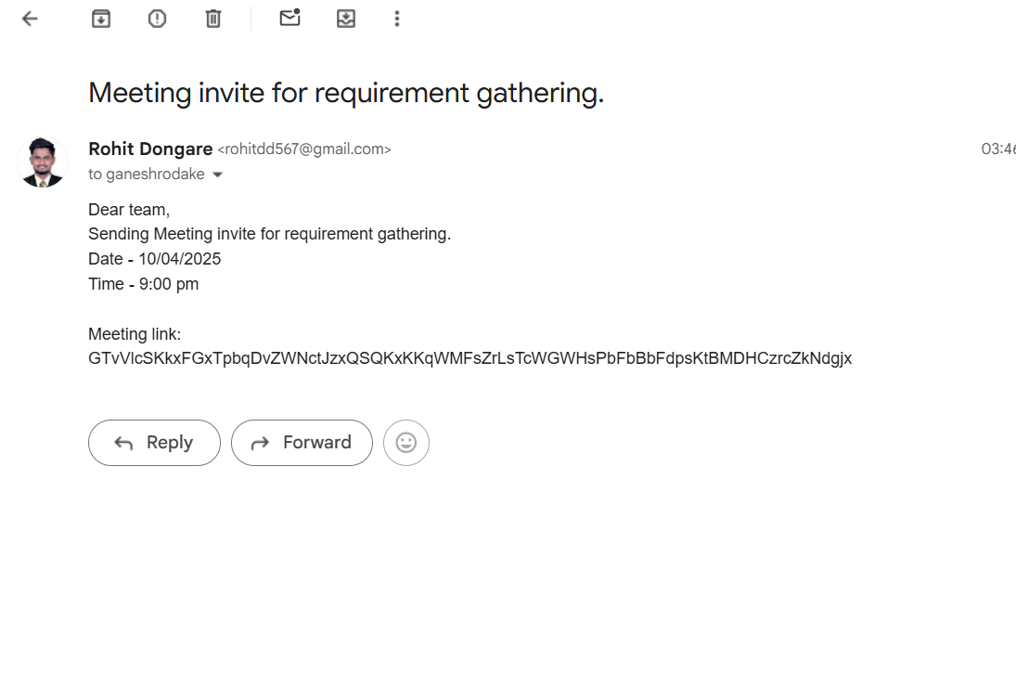

**Minutes of meeting:**

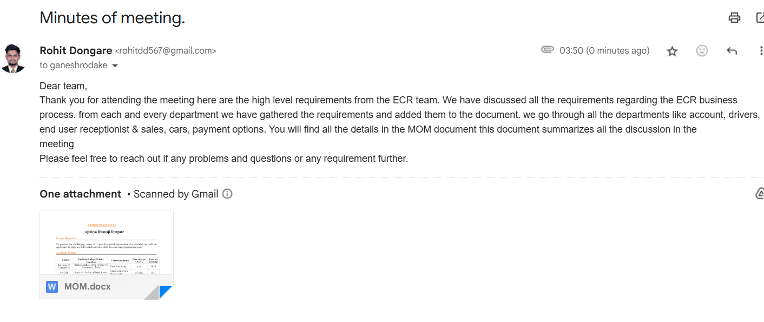

**Minutes of meeting: Client name:** Easy car rental Pvt ltd

**Date:** Wednesday, 19/03/2025 Thane 400080

**Time:** 5 pm to 6.30 pm

**Company name:** ABC tech

Pune 411041

**Topic:** Meeting with owner (M.D) of Easy Car Rental Organisation.

**Attendees:** 2(Two)

|  |  |  |
| --- | --- | --- |
| **Name** | **Designation** | **Present/absent status** |
| Mr. Omkar Pathak | M.D (Easy Car Rental) | Present |
| Rohit Dongare | Business Analyst | Present |

**Meeting agenda:**

To Study As is Business Process of Easy Car Rental (ECR) Organisation.

1) ECR is an organization which works manually and has only one branch which is situated in Mumbai

(Thane).They have 60 cars, 30 drivers & provide service in different states. They spread their business by advertising offline & digital marketing such as Social media platforms like FB (Meta), Twitter, Instagram, LinkedIn, etc.

2) ECR has three different departments: the Reception Department, the Accounts department, and the Admin department. Each department has its own functionalities according to its task. Workers and employees work 24* 7 with different shifts, each lasting 8 hours.

3) When customer visit ECR office employees of ECR collect information on form which include Name, Address, Contact No, E-mail Id along with Govt id proof & where to pick up, destination source, Date of travelling, no of passengers etc. Booking process is done within ½ hrs and do not have any feedback form.

4) 50% advance payment has to done by a customer while booking and remaining 50% before going on ride. They accept all types of payment modes including cash, wallet, card & online payment options & do not provide any insurance policy.

5) Car Bookings depend on session like weekends, festival holidays. Availability of car is done by marking mark on calendar/register that which car is available at the specific date/movement and then customer can select from it. Same process is applied for drivers.

6) Car allocation is done when ECR employee shares Customer location to the driver then driver visits the location for pickup. If any customer has any doubt or issue then he can connect customer care support of ECR through phone calls

7) Reception team maintain all history of customer & Accounts team closes the booking.

8) If there are any offers and discounts then reception team tells them orally while Enquiry or by sending SMS to existing customers they also posts advertisements on social platforms do not provide any type of brochure/template.

9) Customer care executive Mr. Dinesh from ECR will provide all information collected from customer while booking. Pickup and dropping location details list. Pickups are allowed within 30km range in Mumbai city near thane dropping location can choose from the list both location can’t be change once done.

10) ECR contain Sedan, Hatchback & XUV cars. The exact number and information of cars will be given by Mr. Anand head of Car maintenance dept.

11) Maximum capacity of passengers depend on car ex- if four seater excluding driver passengers should be three and if eight seater seven passengers are allowed. They do not charge by any of passenger so there is no minimum or minimum age criteria but if the total no of passengers are more than the car capacity then customer has to book another car without any other solution.

12) Customer is allowed to do Changes or modifications anytime. If the customer wants to delay travel at night then he has to pay one thousand per night extra charge he also has to pay if there is any toll charge on the traveling road because ECR didn’t have fast tag.

13) Accounts Dept. head Bhakti will provide all details about the cancellation process and the refund amount

14) Destination does not affect the discounts it is depends on the total amount paid by customer

15) Charge is done by including GST 18%.Total no of km*Car charges + No of nights 1000 rs all details are written on manual receipt.

16) If any problem occurs while journey and car stopped within 10 km radius from ECR office then another car is sent to resolve the problem otherwise 100% refund is given to customer and they are free to visit another travel company.

**Master table for customer information:**

|  |  |  |  |  |  |  |  |  |  |
| --- | --- | --- | --- | --- | --- | --- | --- | --- | --- |
| **Customer ID** | **Full name** | **Email** | **Contact** | **Account creation date** | **Account status** | **Customer type** | **Total transactions** | **Preferred product** | **Loyalty status** |
| CUS2115 | Easy car rental | ECR@gmail.com | 84XXX4 | 15/2/25 | Active | Corporate | 35 | mobile application | Gold |

# Master table for city information:

|  |  |  |  |  |  |  |  |  |
| --- | --- | --- | --- | --- | --- | --- | --- | --- |
| **City ID** | **City name** | **State** | **Country** | **Pin code** | **Region** | **Time zone** | **Population** | **Created At** |
| CITY001 | Mumbai | Maharashtra | India | 400001 | West | IST | |  | | --- | | 20,961,472 |  |  | | --- | |  | | 2025-03-11 |

# Master table for car information:

|  |  |  |  |  |  |  |  |  |  |  |
| --- | --- | --- | --- | --- | --- | --- | --- | --- | --- | --- |
| **Car ID** | **Car ID** | |  | | --- | | **Make** |  |  | | --- | |  | | **Model** | **Year** | **Fuel Type** | **Seating**  **Capacity** | **Rental Rate Per Day** | **Created At** |
| CAR001 | MH01AB1234 | Hyundai | Aura | 2022 | Petrol | 5 | |  | | --- | | 200 |  |  | | --- | |  | | 2025-03-11 |

# Chapter 4-Unified Modelling Language (UML)

UML is an industry-standard language for specifying, visualizing, constructing, documenting, and understanding software systems.

UML diagrams are of two types:

1. Structural UML
   1. Entity relationship diagram
   2. Class diagram
2. Behavioural UML
3. Flowchart Diagram
4. Activity Diagram
5. ER Diagram
6. Class Diagram
7. Use Case Diagram
8. Sequence Diagram
9. Data Flow Diagram
10. Flowchart Diagram

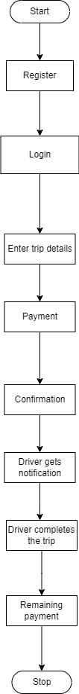

1. Activity Diagram

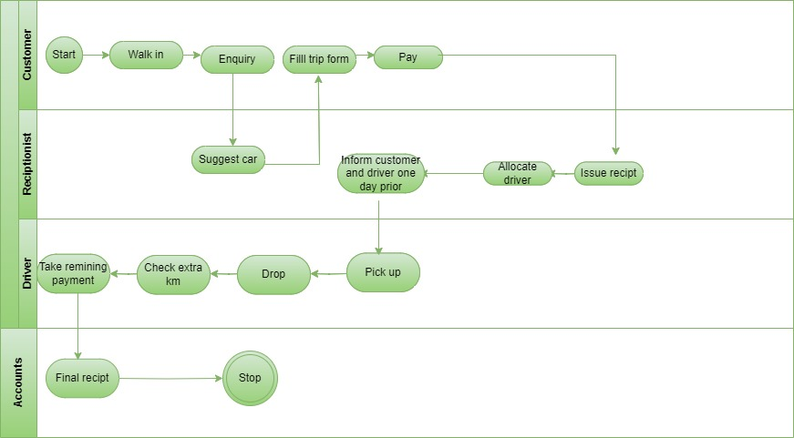

1. Entity-Relationship (ER) Diagram

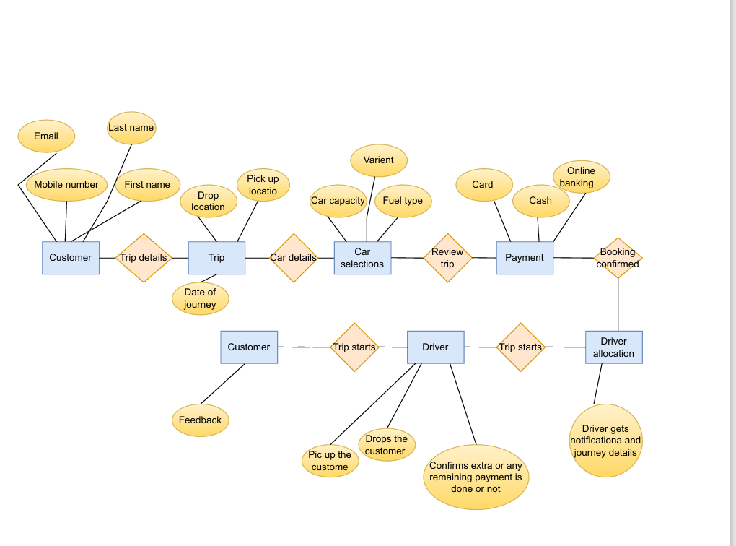

1. Use Case Diagram

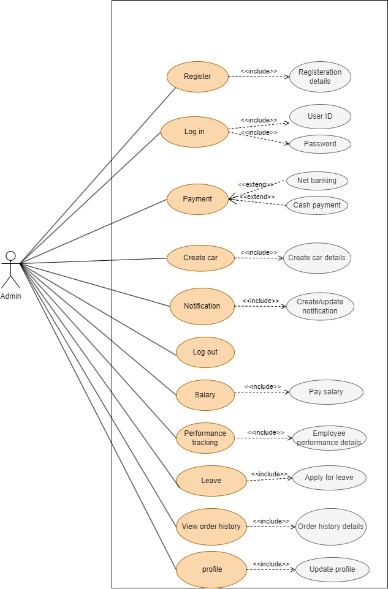

1. Sequence Diagram

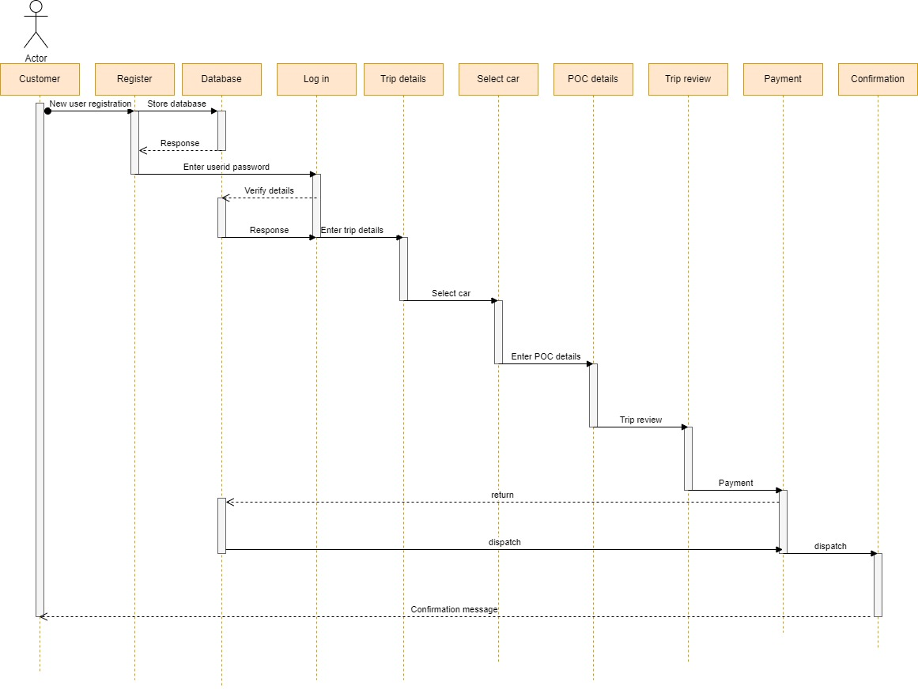

1. Data Flow Diagram DFD

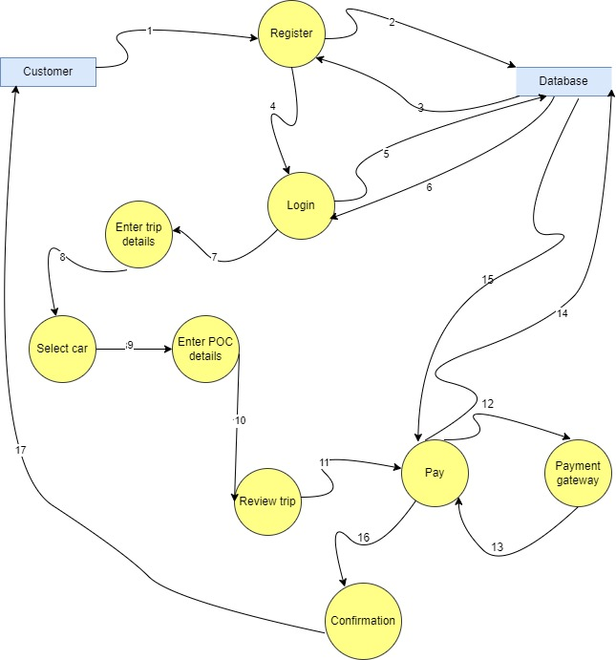

# Chapter 5: Documentation

**RACI matrix:**

RACI matrix is tabular form Which is created and maintained by business analyst. It is mostly used for four key responsibilities Responsible, Accountable, Consulted, and Informed. It is used for clarifying and defining roles and responsibilities in cross-functional or departmental projects and processes.

1) R = Responsible: The responsible person is the individual(s) who actually complete task.

2) A= Accountable: The accountable person is the individual who is ultimately answerable for the activity.

3) C = Consultation: They are consultant person who are Stakeholder

Or Subject matter expert.

4) I = Informed: They are person who impact from the results.

RACI matrix is basically a referenced data for proper coordination of BA with client team which helps in getting proper requirement. RACI Matrix is prepared by BA for getting POC (Point of contact) who is responsible for which task. It reflect ease of contact with concern person.

**RACI matrix is in case of Easy car rental Shown below:**

|  |  |  |  |  |  |  |  |
| --- | --- | --- | --- | --- | --- | --- | --- |
| **Sr. number** | **Department name** | **Point of contact** | **Designation** | **Mobile number** | **Email** | **Time zone** | **RACI** |
| **1** | Operations | Peter | Head | 84XXX4 | abcgmail.com | UTC-5 | R |
| **2** | Business operation | John | Head | 84XXX4 | abcgmail1com | UTC-5 | A |
| **3** | Accounts | Albert | Sr. associate | 84XXX4 | abcgmail2.com | UTC-5 | C |
| **4** | Sales | Henry | Sr. Associate | 84XXX4 | abcgmail3.com | UTC-5 | I |

# 

# Business requirement document (BRD):

**Project name:** Easy car rental

|  |  |  |  |  |  |
| --- | --- | --- | --- | --- | --- |
| **Version** | **Prepared by** | **Prepared date** | **Review by** | **Review date** | **Change log** |
| V1.0 | Rohit Dongare | 15/03/2025 | Mr. Omkar Pathak sir | 20/03/2025 | NA |
|  |  |  |  |  |  |
|  |  |  |  |  |  |

**1. Problem statement:**

**1.1 Maintain data Manually:**

Client’s as is working procedure is manual to maintain the records. It is time consuming and difficult to use the data.

**1.2 Human Errors:**

Because of complex business process it is very difficult to update everything every time so there is difficult to tracking every single modification, payments information and refund information.

**1.3 Less Customer Reach:**

Company has their office in several areas so customer is not aware of that office as well as every time they have to come in office for car booking so it is not possible to reach every customer in less time.

**1.4** **More investment required:**

In the current business process, it is needed high number of human resources, printers, electronic gadgets, hard copies etc. all you have to invest more in these things and these things are naturally overcome with our application.

**1.5 Refund process:**

Refund procedure is also hectic as well as time consuming.

**1.6 Complicated payment process:**

Payment procedure is really hectic because you have to maintain every person payment records sometimes, they have also faced change problem as well as when it’s any offer going on so update payment estimation manually every time.

**1.7 Data storage and access:**

You have to maintain all data records in hard copies, printers, inks like customer booking information, their payment data, their address proof etc. If in case we have to find any records we have search it manually it is very time consuming.

**1.8 Manual reminder:**

You always need to inform driver by calling or by meeting him and always telling him some repetitive tasks also you need to inform driver personally for every pick up and drop facility. And driver also need to inform personally their status to management team.

**1.9 Complicated cancellation process:**

If you want to cancel your ride in emergency or any situation so you have to visit office for cancelling your ride as well the full booking procedure is cancelled from scratch and it is really difficult to maintain this type of data.

**1.10 Time consuming process:**

Because of maintaining all data manually and maintain hard copies it is really time consuming.

**2 Project scope: (Goal of a project)**

To make car booking procedure easy and convenient for customers and make data management easier for client by giving them mobile application for that problem.

|  |  |  |  |
| --- | --- | --- | --- |
| **Product Features of Customer** | | | |
| **Category** | **Section** | **Actions** | **Sub-Actions** |
| **Authentication** | Login | Login | Enter credentials (email/username, password) & Authenticate. |
| **Book car** | Car booking | Car booking | Select car and trip details |
| **Registration** | Register | Register | Submit registration details. |
| **Refund** | Demand for refund | Demand for refund | Enter refund reason |
| **Profile** | Edit Profile | Edit Profile | Change the necessary details and submit |
| **Order** | Create/Update/Delete Booking | Create/Update/Delete Booking | Edit the booking entter necessary details. |
| **Payment** | Create/Update Payement | Create/Update Payement | Enter payment method and proceed. |
| **Log out** | Log out | Log out | Press the log out button and confirm. |
| **POC** | Point of contact details | Point of contact details | Enter Point of contact details |
| **View** | View available cars | View available cars | View available cars |
| **Feedback** | Feedback | Feedback | Add feedback to textbox and submit. |
| **Cancellation** | Cancel Order | Cancel Order | Enter the reason for cancellation and cancel the order. |
| **Trip history** | Trip history | Trip history | Click on trip history. |

|  |  |  |  |
| --- | --- | --- | --- |
| **Product Features of Admin** | | | |
| **Category** | **Section** | **Actions** | **Sub-Actions** |
| **Authentication** | Login | Login | Enter credentials (email/username, password) & Authenticate. |
| **Trancsactions** | Track transactions | Transactions | Click on view transactions. |
| **Registrations** | Register | Register | Submit registration details. |
| **Provide promocode** | Provide promocode | Go on promocode option | Enter credentials. |
| **Profile** | Edit Profile | Edit Profile | Change the necessary details and submit |
| **Holiday** | Create/Update/Delete Holiday | Create/Update/Delete Booking | Edit the holiday entter necessary details. |
| **Payment** | Create/Update Payement | Create/Update Payement | Enter payment method and proceed. |
| **Logout** | Log out | Log out | Press the log out button and confirm. |
| **Roles** | Create roles | Click on roles. | Enter necessary details. |
| **Product Features of Admin** | Create/Update/Delete car | Create/Update/Delete car | Enter in edit car. |
| **Feedback** | Feedback | Feedback | Add feedback to textbox and submit. |
| **Purchase rate** | User purchase rate | User purchase rate |  |
| **Refund** | Update refund | Click on refund | Enter reason for refund and refund amount. |
| **Assign vehucle for the journey** | Assign vehucle for the journey | Assign vehucle for the journey | Click on vehilc assign |
| **Car service** | View car service details | View car service details | View car service details |

|  |  |  |  |  |  |  |  |
| --- | --- | --- | --- | --- | --- | --- | --- |
| **Product Features of Customer support** | | | | | | | |
| **Category** | | **Section** | | **Actions** | | **Sub-Actions** | |
| **Authentication** | | Login | | Login | | Enter credentials (email/username, password) & Authenticate. | |
| **Read booking** | | Bookings | | Bookings | | Read booking details | |
| **Registration** | | Register | | Register | | Submit registration details. | |
| **Chat option** | | Chat | | Chat | | Chat with customer | |
| **Profile** | | Edit Profile | | Edit Profile | | Change the necessary details and submit | |
| **Mail** | | Email | | Email | | Send mail | |
| **Feedback** | | Read feedback | | Read feedback | | Read feedback and respond. | |
| **Log out** | | Log out | | Log out | | Press the log out button and confirm. | |
| **Alert** | | Maintainance | | Maintainance | | Click on create alert. | |
| **View** | | View Car | | View Car | | Home page you can view the Car. | |
|  | |  | |  | |  | |
|  | |  | |  | |  | |
| **Product Features of Driver** | | | | | | |
| **Category** | **Section** | | **Actions** | | **Sub-Actions** | |
| **Authentication** | Login | | Login | | Enter credentials (email/username, password) & Authenticate. | |
| **View booking details** | View booking details | | View booking details | | View booking details | |
| **Registrations** | Register | | Register | | Submit registration details. | |
| **Read Feedback** | Read Feedback | | Read Feedback | | Click on read Feedback | |
| **Profile** | Edit Profile | | Edit Profile | | Change the necessary details and submit | |
| **Read payment Details** | Read payment Details | | Read payment Details | | Read payment Details | |

|  |  |  |  |
| --- | --- | --- | --- |
| **Product Features of accounts** | | | |
| **Category** | **Section** | **Actions** | **Sub-Actions** |
| **Authentication** | Login | Login | Enter credentials (email/username, password) & Authenticate. |
| **Products** | Track Number of products | Track Number of products | Click on Product details |
| **Registrations** | Register | Register | Submit registration details. |
| **Creating Budget report** | Creating Budget report | Creating Budget report | Click on budget report. |
| **Analysing Final accounts** | Analysing Final accounts | Analysing Final accounts | Click on final accounts |
| **Providing receipt** | Providing receipt | Providing receipt | Edit the holiday entter necessary details. |
| **Paying salary** | Paying salary | Paying salary | Enter payment method and proceed. |
| **Payment history** | Payment history | Payment history | Press the log out button and confirm. |

1. **As is business process:** 
   1. **UML Diagram on High Level**

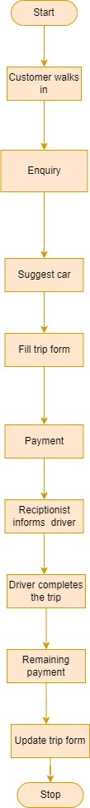

**Activity diagram:**

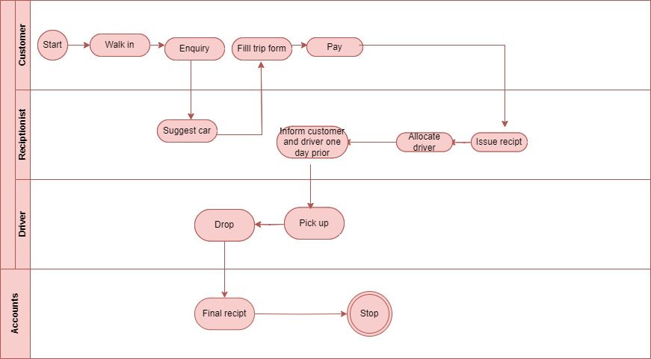

**As is business process description:**

1. The car is booked by the customer in the office as per destination of the client.

An advance 50% payment is taken from the customer after the booking is done the mode of payment is by via cash or card

2. Customers firstly come to office and talk to the receptionist to explain their requirements and need.

3. According to customers’ needs the receptionist books a car for them. The car, pick up and drop off destinations, time, date, trip fare - everything is decided here.

4. Customer has to pay 50% of the trip fee in advance. He/she then signs terms and conditions document and submits a copy of their photo ID as proof.

5. All the trip and customer details are recorded by the receptionist.

6. A driver is assigned for the trip.

7. On the set date, time and location the driver picks up the client.

8. After drop off the remaining 50% of the trip fee is paid by the customer.

9. More detail overview of the business will be taken from the SME of the client

1. **To-Be Business Process:**

ECR will automate the manual car reservation process which was carried out by going to the business place or using a phone call. Customers provide information to this application by filling in their personal information. When a customer creates an account on the application, he or she can reserve a car. The proposed system is an online system that is fully integrated. It effectively and efficiently automated manual procedures. Customers are aided by this automated method, which allows them to fill in the specifics according to their needs. It contains information on the sort of car they want to hire as well as the location. The goal of this system is to create a mobile application where customers can book their automobiles and request services online. There are three phases to this car rental system mentioned in the introduction.

ECR mobile application allows new users to register online and generate login details. Customer can use the application to make booking and online reservation. Customer can search the available car by entering trip details on desired date and time. Customer can select an available car and able to proceed payment. Customer can track the detailed information of car booking, payment, driver details.

**UML diagram on high-level:**

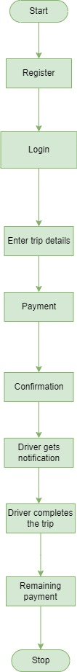

**Activity diagram:**



1. **Functional requirements:**

**UI-SCREENS FOR ECR**

**Registration:**

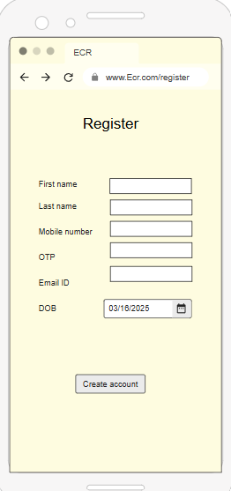

* 1. **UI Screen for registration:**
* First & Last Names should be max 30 character. [Mandatory field].
* Enter Email ID & Mobile number. [Mandatory field].
* Enter OTP for mobile number and email respectively. [Mandatory field].
* Create a password containing at least one number and alphabets and repeat it.

[Mandatory field].

* Enter DOB and create the account. [Mandatory field].
  1. **UI screen for log in page:**
* User ID should be 8 to 15 letters [no special character/symbol].
* Create a password containing at least one number and alphabets and repeat it.

[Mandatory field].

* Below user ID/Pass registration for new user.
* If user forgets his login id or password he can click on Forgot Password.

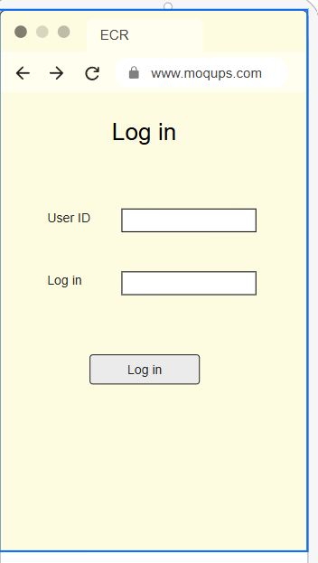

* 1. **UI screens for trip details:**
* Enter your location details.
* Enter your drop location.
* Select the date of your journey.
* Enter number of travellers.
* Enter type of car and submit.

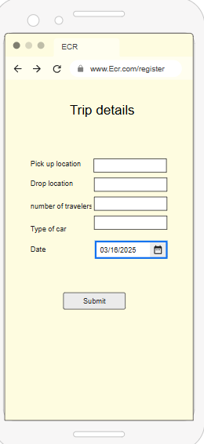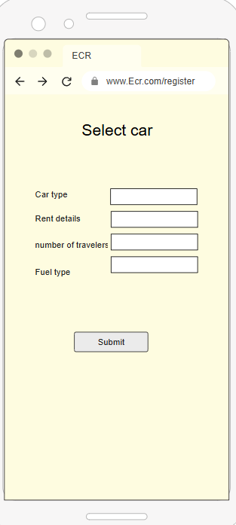

* 1. **UI Screens for payment methods:**
* In Select payment method where customer will choose a type by swipe [Debit/Credit].
* VISA, MASTER and Rub Pay card customer has to choose one.
* Net Banking can choose from drop down list there is a drop-down list.
* Cash on Delivery selecting customer has to do pay cash.

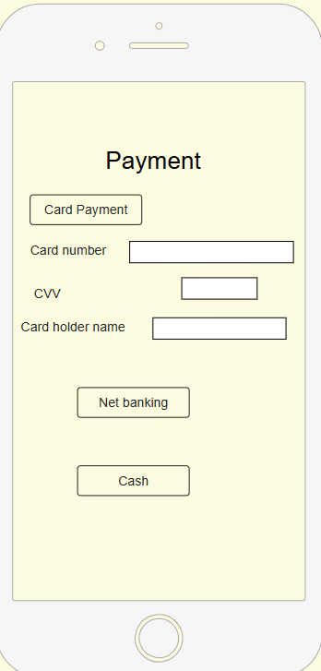

* 1. **UI screens for pay receipt:**
* After doing the payment user can see payments payment successful message (in case of successful transaction) & can generate receipt.

1. **Non-functional requirements:**
   1. **UI requirements:**

* User Interface requirement is simple and easy appearance
* Colour of text, foreground and background will be contrast.
  1. **Software requirement:**
* Any operating system can be used with help of internet browser.
  1. **Hardware Requirement**
* Processor minimum i5 and HDD 250 GB/RAM minimum 8 GB.

1. **Assumptions and constraints:**

**1) Assumptions:**

* 1. ECR application will be entirely managed by the administration.
  2. End user should be of 18+ age.
  3. Driver will be provided by ECR only.
  4. Every user has account created and authenticated by the administration.
  5. Unless the payment phase is completed, the system will not allow to perform the booking & renting capabilities.
  6. ECR application will work on server that needs to be always online.

**2) Constraints:**

1. Response time for loading the product should take no longer than five minutes.
2. Limit for file upload size is 300 mb maximum.
3. All import data will be available in pdf, doc format.
4. Application language only in English.
5. Default currency type will be Indian rupees.

# Software requirement specifications:

* + - 1. **Problem Statement:**

|  |  |  |  |  |  |
| --- | --- | --- | --- | --- | --- |
| **Version** | **Prepared by** | **Prepared date** | **Review by** | **Review date** | **Change log** |
| V1.0 | Rohit Dongare | 15/03/2025 | Mr. Omkar Pathak sir | 20/03/2025 | NA |
|  |  |  |  |  |  |
|  |  |  |  |  |  |

**1.1 Maintain data Manually:**

Client’s as is working procedure is manual to maintain the records. It is time consuming and difficult to use the data.

**1.2 Human Errors:**

Because of complex business process it is very difficult to update everything every time so there is difficult to tracking every single modification, payments information and refund information.

**1.3 Less Customer Reach:**

Company has their office in several areas so customer is not aware of that office as well as every time they have to come in office for car booking so it is not possible to reach every customer in less time.

**1.4** **More investment required:**

In the current business process, it is needed high number of human resources, printers, electronic gadgets, hard copies etc. all you have to invest more in these things and these things are naturally overcome with our application.

**1.5 Refund process:**

Refund procedure is also hectic as well as time consuming.

**1.6 Complicated payment process:**

Payment procedure is really hectic because you have to maintain every person payment records sometimes, they have also faced change problem as well as when it’s any offer going on so update payment estimation manually every time.

**1.7 Data storage and access:**

You have to maintain all data records in hard copies, printers, inks like customer booking information, their payment data, their address proof etc. If in case we have to find any records we have search it manually it is very time consuming.

**1.8 Manual reminder:**

You always need to inform driver by calling or by meeting him and always telling him some repetitive tasks also you need to inform driver personally for every pick up and drop facility. And driver also need to inform personally their status to management team.

**1.9 Complicated cancellation process:**

If you want to cancel your ride in emergency or any situation so you have to visit office for cancelling your ride as well the full booking procedure is cancelled from scratch and it is really difficult to maintain this type of data.

**1.10 Time consuming process:**

Because of maintaining all data manually and maintain hard copies it is really time consuming.

* + - 1. **Project scope: (Goal of a project)**

To make car booking procedure easy and convenient for customers and make data management easier for client by giving them mobile application for that problem.

|  |  |  |  |
| --- | --- | --- | --- |
| **Product Features of Customer** | | | |
| **Category** | **Section** | **Actions** | **Sub-Actions** |
| **Authentication** | Login | Login | Enter credentials (email/username, password) & Authenticate. |
| **Book car** | Car booking | Car booking | Select car and trip details |
| **Registration** | Register | Register | Submit registration details. |
| **Refund** | Demand for refund | Demand for refund | Enter refund reason |
| **Profile** | Edit Profile | Edit Profile | Change the necessary details and submit |
| **Order** | Create/Update/Delete Booking | Create/Update/Delete Booking | Edit the booking entter necessary details. |
| **Payment** | Create/Update Payement | Create/Update Payement | Enter payment method and proceed. |
| **Log out** | Log out | Log out | Press the log out button and confirm. |
| **POC** | Point of contact details | Point of contact details | Enter Point of contact details |
| **View** | View available cars | View available cars | View available cars |
| **Feedback** | Feedback | Feedback | Add feedback to textbox and submit. |
| **Cancellation** | Cancel Order | Cancel Order | Enter the reason for cancellation and cancel the order. |
| **Trip history** | Trip history | Trip history | Click on trip history. |

|  |  |  |  |
| --- | --- | --- | --- |
| **Product Features of Admin** | | | |
| **Category** | **Section** | **Actions** | **Sub-Actions** |
| **Authentication** | Login | Login | Enter credentials (email/username, password) & Authenticate. |
| **Trancsactions** | Track transactions | Transactions | Click on view transactions. |
| **Registrations** | Register | Register | Submit registration details. |
| **Provide promocode** | Provide promocode | Go on promocode option | Enter credentials. |
| **Profile** | Edit Profile | Edit Profile | Change the necessary details and submit |
| **Holiday** | Create/Update/Delete Holiday | Create/Update/Delete Booking | Edit the holiday entter necessary details. |
| **Payment** | Create/Update Payement | Create/Update Payement | Enter payment method and proceed. |
| **Logout** | Log out | Log out | Press the log out button and confirm. |
| **Roles** | Create roles | Click on roles. | Enter necessary details. |
| **Product Features of Admin** | Create/Update/Delete car | Create/Update/Delete car | Enter in edit car. |
| **Feedback** | Feedback | Feedback | Add feedback to textbox and submit. |
| **Purchase rate** | User purchase rate | User purchase rate |  |
| **Refund** | Update refund | Click on refund | Enter reason for refund and refund amount. |
| **Assign vehucle for the journey** | Assign vehucle for the journey | Assign vehucle for the journey | Click on vehilc assign |
| **Car service** | View car service details | View car service details | View car service details |

|  |  |  |  |  |  |  |  |
| --- | --- | --- | --- | --- | --- | --- | --- |
| **Product Features of Customer support** | | | | | | | |
| **Category** | | **Section** | | **Actions** | | **Sub-Actions** | |
| **Authentication** | | Login | | Login | | Enter credentials (email/username, password) & Authenticate. | |
| **Read booking** | | Bookings | | Bookings | | Read booking details | |
| **Registration** | | Register | | Register | | Submit registration details. | |
| **Chat option** | | Chat | | Chat | | Chat with customer | |
| **Profile** | | Edit Profile | | Edit Profile | | Change the necessary details and submit | |
| **Mail** | | Email | | Email | | Send mail | |
| **Feedback** | | Read feedback | | Read feedback | | Read feedback and respond. | |
| **Log out** | | Log out | | Log out | | Press the log out button and confirm. | |
| **Alert** | | Maintainance | | Maintainance | | Click on create alert. | |
| **View** | | View Car | | View Car | | Home page you can view the Car. | |
|  | |  | |  | |  | |
|  | |  | |  | |  | |
| **Product Features of Driver** | | | | | | |
| **Category** | **Section** | | **Actions** | | **Sub-Actions** | |
| **Authentication** | Login | | Login | | Enter credentials (email/username, password) & Authenticate. | |
| **View booking details** | View booking details | | View booking details | | View booking details | |
| **Registrations** | Register | | Register | | Submit registration details. | |
| **Read Feedback** | Read Feedback | | Read Feedback | | Click on read Feedback | |
| **Profile** | Edit Profile | | Edit Profile | | Change the necessary details and submit | |
| **Read payment Details** | Read payment Details | | Read payment Details | | Read payment Details | |

|  |  |  |  |
| --- | --- | --- | --- |
| **Product Features of accounts** | | | |
| **Category** | **Section** | **Actions** | **Sub-Actions** |
| **Authentication** | Login | Login | Enter credentials (email/username, password) & Authenticate. |
| **Products** | Track Number of products | Track Number of products | Click on Product details |
| **Registrations** | Register | Register | Submit registration details. |
| **Creating Budget report** | Creating Budget report | Creating Budget report | Click on budget report. |
| **Analysing Final accounts** | Analysing Final accounts | Analysing Final accounts | Click on final accounts |
| **Providing receipt** | Providing receipt | Providing receipt | Edit the holiday entter necessary details. |
| **Paying salary** | Paying salary | Paying salary | Enter payment method and proceed. |
| **Payment history** | Payment history | Payment history | Press the log out button and confirm. |

* + - 1. **As is existing business process low-level:**

**Description:**

* The customer walks in the office where the office is located.
* He/she enquires at reception.
* In reception area the customer got information they suggest the car. And according to that customer fills the form.
* According to customers’ needs the receptionist books a car for them. The car, pick up and drop off destinations, time, date, trip fare - everything is decided here.
* The car is booked by the customer in the office as per destination of the client. An advance 50% payment is taken from the customer after the booking is done the mode of payment is by via cash or card.
* Customer issue receipt of advance payment here
* All the trip and customer details are recorded by the receptionist.
* A driver is assigned for the trip.
* On the set date, time and location the driver picks up the customer.
* Driver checks the extra kms.
* After drop off the remaining 50% of the trip fee is paid by the customer.
* Again, customer issue receipt of full payment
* Driver inform receptionist and receptionist update trip form.
* Driver close the booking.

**Flow chart:**



**Activity diagram**



* + - 1. **To be business process on low-level:**

ECR will automate the manual car reservation process which was carried out by going to the business place or using a phone call. Customers provide information to this application by filling in their personal information. When a customer creates an account on the application, he or she can reserve a car. It contains information on the sort of car they want to hire as well as the location. ECR mobile application allows car rental admin (system) to login with username and password. Admin can use the application to confirm car booking and online reservation. Admin can allocate the available car and driver to customer on desired date and time. Admin share trip details and customer contact details with driver. For payment procedure admin can check difference in kilometres and can calculate total fare. Admin can issue receipt to customer by using application.

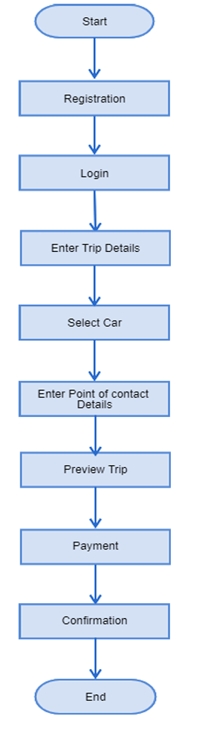

Activity diagram:

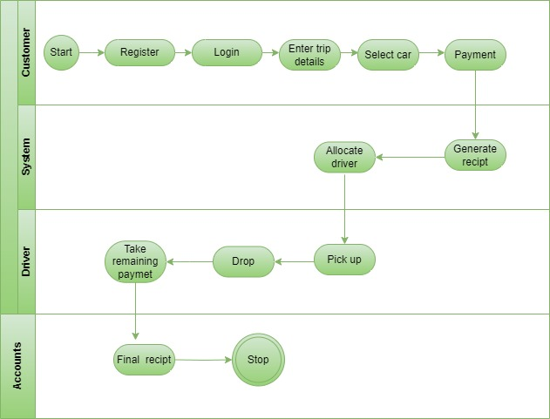

1. Entity-Relationship (ER) Diagram



An Entity-Relationship (ER) Diagram plays a crucial role in database design by visually representing the structure and relationships of data within a system. It helps define the entities (such as Customer, Car, Admin, and Booking), their attributes (e.g., customer name, car type, booking date), and the relationships between them (e.g., a customer can make multiple bookings, a car is assigned to a driver). The ER diagram ensures a well-organized database, making it easier to manage data integrity, optimize queries, and support system development. It serves as a blueprint for database architects and developers, ensuring a structured and efficient data model.

1. Use Case Diagram

Customer

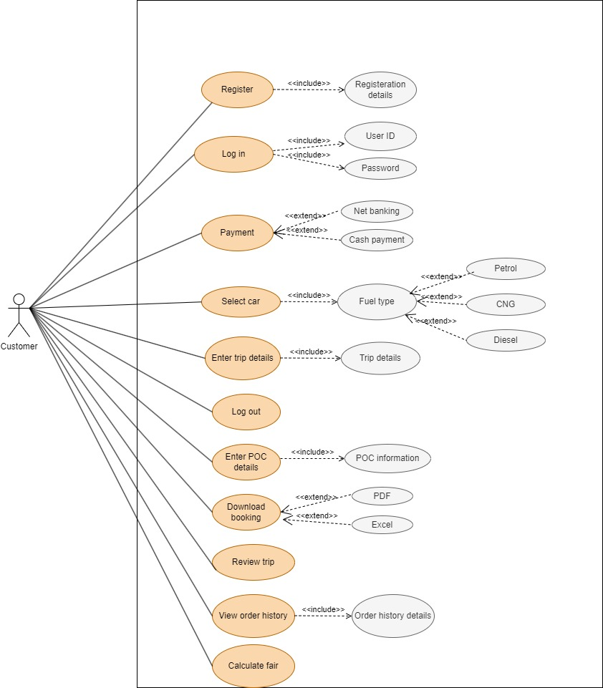

Accounts

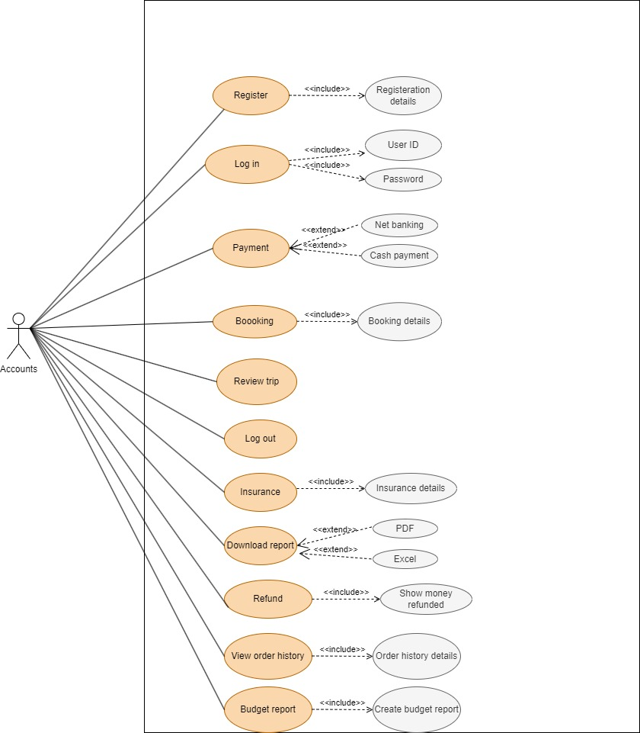

Driver

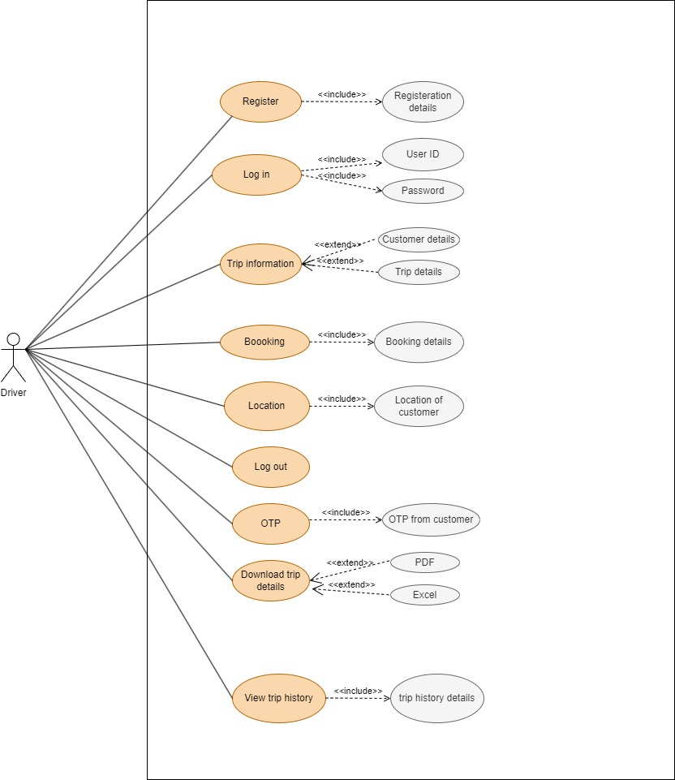

Admin



Customer support

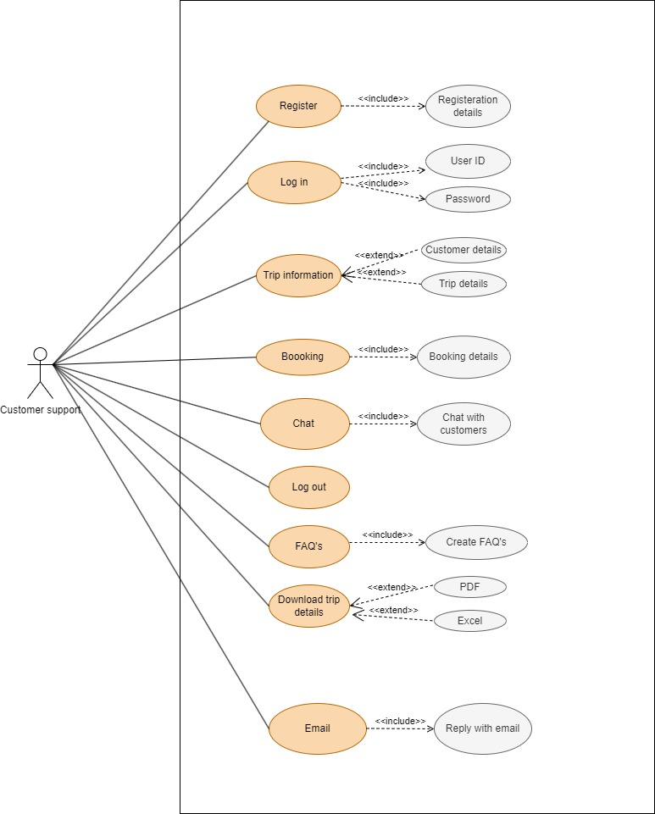

1. Sequence Diagram



The Sequence Diagram illustrates the step-by-step interaction between the Customer, Admin, System, and Driver in the Easy Car Rental (ECR) application. The process begins when the Customer registers and logs in to the system. After logging in, the customer selects a car, provides trip details, and submits a reservation request. The Admin logs in, reviews the request, and confirms the booking. The system then allocates a car and driver, sharing trip details with the assigned driver. Upon trip completion, the admin calculates the fare based on distance travelled, and the customer makes the payment. Finally, the system generates a receipt for the customer. This sequence ensures a smooth, automated workflow for both customers and administrators.

1. Data Flow Diagram DFD



The Data Flow Diagram (DFD) illustrates the process of booking a car through the Easy Car Rental application. It begins with the Customer, who searches for a car and submits a booking request. The Easy Car Rental System processes the request by checking the Car Inventory for availability. If the car is available, the system proceeds with Customer Authentication and Payment Processing, interacting with an external Payment Gateway. Once the payment is confirmed, the system finalizes the booking and sends a Booking Confirmation to the customer. The updated booking details are stored in the system for future reference. This structured flow ensures a seamless and automated car rental experience.

**Functional specifications:**

**Registration:**

|  |  |  |  |  |  |  |  |  |  |  |  |
| --- | --- | --- | --- | --- | --- | --- | --- | --- | --- | --- | --- |
| Use Case ID: | | | | | Ucid001 | Prepared By | | | Rohit Dongare | | |
|  | | | | | | Prepared Date | | | --/--/---- | | |
| Use Case Name: New user can register. | | | | | | | | | | | |
| Use case Diagram: | | | | | | | | | | | |
| **Actors:** New user | | | | | | | | | | | |
| **Pre -Condition** | | | | | | | | | | | |
| 1. User must be 18+ | | | | | | | | | | | |
| **Successful Post Condition** | | | | | | **Unsuccessful Post Condition** | | | | | |
| 1. Show pop-up window with message ‘user registration is successful’ 2. Click on ok button navigate to login pagsse. | | | | | | 1. User stay on registration page 2. Show validation message below field name in color red font arial size 10. 3. Please refer validation message in field validation table. | | | | | |
| **Basic Flow** | | | | | | **Alternate flow** | | | | | |
| 1. Click on register link in top right corner of home page. 2. User enters mandatory fields. 3. Click on ‘submit’ button | | | | | | 1. Click on register link on footer and pre payment page. 2. Fill mandatory fields. 3. Click on submit button. | | | | | |
| **Field Validation Table** | | | | | | | | | | | |
| Sr. No | Field Name | Control type | Data type | Length | Default Value | Other Value | Functional Requirement | Business Rule | | Validation Role | Validation Message |
| 1 | Name | Text Box | Character | 50 | Please Enter your name | NA | Please Enter Username | NA | | 1.Mandatory | For validation Rule 1 show below message. ‘Please enter name’ |
| 2.No Space Before/After/ inbetween | For validation Rule 2 show below message. ‘Please enter name without  space’ |
| 3.Character only | For validation Rule 3 show below message. ‘Please enter character  only’ |
| 2 | OTP | Text Box | Numeric | 10 | Please Enter mobile numner | NA | Please Enter mobile numner | NA | | 1.Mandatory | For validation Rule 1 show below message. ‘Please enter  OTP |
| 2.No Space Before/After/ in-between | For validation Rule 2 show below message. ‘Please enter OTP  without space’ |
| 3.Numeric only | For validation Rule 3 show below message. ‘Please enter  Numeric value only’ |
| 3 | OTP | Text Box | Numeric | 6 | Please Enter OTP | NA | Please Enter OTP | NA | | 1.Mandatory | For validation Rule 1 show below message. ‘Please enter  OTP |
| 2.No Space Before/After/ in-between | For validation Rule 2 show below message. ‘Please enter OTP  without space’ |
| 3.Numeric only | For validation Rule 3 show below message. ‘Please enter  Numeric value only’ |
| 4 | Password | Text Box | Alphanumeric | 8 | Please Enter Password | NA | Please Enter Password | NA | | 1.Mandatory | For validation Rule 1 show below message. ‘Please enter  Password’ |
| 2.No Space Before/After/ in-between | For validation Rule 2 show below message. ‘Please enter Password  without space’ |
| 3.Alphanumer ic only | For validation Rule 3 show below message. ‘Please enter  Alphanumeric only’ |
| 5 | Address | Text Box | Alphanumeric | 150 | Please enter address | NA | Please enter address | NA | | 1.Mandatory | For validation Rule 1 show below message. ‘Please enter  Address’ |
| 2.Space Before/After/ in-between | For validation Rule 2 show below message. ‘Please enter address  without space’ |
| 3.Alphanumer ic only | For validation Rule 3 show below message. ‘Please enter  Alphanumeric only’ |
| 6 | Submit button | Button | _- | _- | - | _- | - | _- | | 1. Mandatory | For validation, Rule 1 shows the below message. ‘Add to cart the product to purchase it,’  .’ |
| 2.No Space Before/After/ in-between | For validation Rule 2 show below message. ‘Please enter Password  without space’ |
| 3.Alphanumer ic only | For validation Rule 3 show below message. ‘Please enter  Alphanumeric only’ |

**Use Case Specification (User Login)**

|  |  |  |  |  |  |  |  |  |  |  |  |  |
| --- | --- | --- | --- | --- | --- | --- | --- | --- | --- | --- | --- | --- |
| Use Case ID: | | | | | Ucid01 | Prepared By | | | Rohit Dongare | | | |
|  | | | | | | Prepared Date | | | --/--/---- | | | |
| Use Case Name: Existing User can Login | | | | | | | | | | | | |
| Use case Diagram: | | | | | | | | | | | | |
| Actors: Existing User | | | | | | | | | | | | |
| **Pre -Condition** | | | | | | | | | | | | |
| 1. User must have valid username & password | | | | | | | | | | | | |
| **Successful Post Condition** | | | | | | **Unsuccessful Post Condition** | | | | | | |
| 1. User must be logged into the system 2. User must navigate to car booking page | | | | | | 1. User stay on Login page 2. User enters the wrong username & password 3. Validation message is shown to user below field name in color ‘Red’ font ‘Arial’ size 10 4. 4. Refer validation message in validation table | | | | | | |
| **Basic Flow** | | | | | | **Alternate flow** | | | | | | |
| 1. System displays a Login page 2. User enters a correct username & password 3. Click on ‘Login’ button | | | | | | Not Applicable | | | | | | |
| **Field Validation Table** | | | | | | | | | | | | |
| Sr. No | Field Name | Control type | Data type | Length | Default Value | Other Value | Functional Requirement | Business Rule | | Validation Role | Validation Message |
| 1 | Username | Text Box | Character | 10-50 | Please Enter User name | NA | Please Enter Username | NA | | 1.Mandatory | For validation Rule 1 show below message. ‘Please enter  Username’ |
| 2.No Space Before/After/ inbetween | For validation Rule 2 show below message. ‘Please enter Username without  space’ |
| 3.Character only | For validation Rule 3 show below message. ‘Please enter character  only’ |
| 2 | Password | Text Box | Alphanumeric | 8 | Please Enter Password | NA | Please Enter Password | NA | | 1.Mandatory | For validation Rule 1 show below message. ‘Please enter  Password’ |
| 2.No Space Before/After/ in-between | For validation Rule 2 show below message. ‘Please enter Password  without space’ |
| 3.Alphanumer ic only | For validation Rule 3 show below message. ‘Please enter  Alphanumeric only’ |

**Use case specification for Trip details:**

|  |  |  |  |  |  |  |  |  |  |  |  |
| --- | --- | --- | --- | --- | --- | --- | --- | --- | --- | --- | --- |
| Use Case ID: | | | | | Ucid02 | Prepared By | | | | Rohit Dongare | |
|  | | | | | | Prepared Date | | | | --/--/---- | |
| Use Case Name: Existing User can Enter Trip Details | | | | | | | | | | | |
| Use case Diagram: | | | | | | | | | | | |
| Actors: Existing User | | | | | | | | | | | |
| **Pre -Condition** | | | | | | | | | | | |
| 1. User must have login into system | | | | | | | | | | | |
| **Successful Post Condition** | | | | | | **Unsuccessful Post Condition** | | | | | |
| 1. Show Enter trip details page after login 2. User can enter pickup and drop location 3. User can select desired time and date 4. Click on ‘Search Cars’ button | | | | | | 1. User stay on Enter trip details page 2. User enters the wrong Pickup & Drop location 3. Validation message is shown to user below field name in color ‘Red’ font ‘Arial’ size 10 4. Refer validation message in validation table | | | | | |
| **Basic Flow** | | | | | | **Alternate flow** | | | | | |
| 1. Enter pickup & drop location 2. Select desired time & date 3. Click on ‘Search Cars’ button | | | | | | Not Applicable | | | | | |
| **Field Validation Table** | | | | | | | | | | | |
| Sr. No | Field Name | Control type | Data type | Length | Default Value | Other Value | Functional Requirement | Business Rule | Validation Role | | Validation Message |
| 1 | Pickup Location | Text Box | Character | 50 | Please Enter Pickup Location | NA | Please Enter Pickup Location | NA | 1.Mandatory | | For validation Rule 1 show below message. ‘Please enter  Pickup Location’ |
| 2.No Space Before/After/ inbetween | | For validation Rule 2 show below message. ‘Please enter Pickup Location  without space’ |
| 3.Character only | | For validation Rule 3 show below message. ‘Please enter  character only’ |
| 2 | Drop Location | Text Box | Character | 50 | Please Enter Drop Location | NA | Please Enter Drop Location | NA | 1.Mandatory | | For validation Rule 1 show below message. ‘Please enter Drop Location’ |
| 2.No Space Before/After/ inbetween | | For validation Rule 2 show below message. ‘Please enter Drop Location  without space’ |
| 3.Alphanumeric only | | For validation Rule 3 show below message. ‘Please enter  Character only’ |

**Use case specification for car selection:**

|  |  |  |  |  |  |  |  |  |  |  |
| --- | --- | --- | --- | --- | --- | --- | --- | --- | --- | --- |
| Use Case ID: | | | Ucid04 | | | Prepared By:- Rohit Dongare | | | | |
|  | | | | | | Prepared Date:- --/--/---- | | | | |
| Use Case Name: Existing user can select car | | | | | | | | | | |
| Use case diagram: | | | | | | | | | | |
| Actors: Existing Customer | | | | | | | | | | |
| **Pre -Condition** | | | | | | | | | | |
| 1. User must be registered & login 2. User Must be 18+ | | | | | | | | | | |
| **Successful Post Condition** | | | | | | **Unsuccessful Post Condition** | | | | |
| 1. Drop-down list will appear along with no. of Cars. 2. User can select car from given list. 3. User can confirm booking of car and see Tick mark in Check-Box. | | | | | | 1. If car is not selected by user then. (SELECT A VALID CAR). Message will be shown 2. Error massage will be shown in colour "red" font " Arial" size "10" | | | | |
| **Basic Flow** | | | | | | **Alternate flow** | | | | |
| 1. User has to Fill all mandatory field. 2. Click on dropdown for car selection. 3. User can select car as per Seats & Fuel (Diesel/Petrol/CNG/Electric) 4. User will see the number of cars along with car images. 5. User has to click on “Add car” button | | | | | | Not Applicable | | | | |
| **Field Validation Table** | | | | | | | | | | |
| **Sr. No** | **Field Name** | **Control type** | **Data type** | **Length** | **Default Value** | **Other Value** | **Functional Requirement** | **Business Rule** | **Validation Rule** | **Validation Message** |
| 1 | Select car | Dropdown | Selection | -- | Select Car | NA | User will click on the option | Update Payment | 1. Fill all mandatory fields 2. Select   Atleast one car. | Validation message for rule 1 & 2  -Add at least one Car from the  given list |

**Use Case Specification (P.O.C)**

|  |  |  |  |  |  |  |  |  |  |  |  |  |
| --- | --- | --- | --- | --- | --- | --- | --- | --- | --- | --- | --- | --- |
| Use Case ID: | | | Ucid03 | | |  | Prepared By:- | | Rohit Dongare | | |  |
|  | | | | | |  | Prepared Date:- | | --/--/---- | | |  |
| Use Case Name: Existing user will submit Point of Contact | | | | | | | | | | | | |
| Actors: Existing Customer has to enter POC Details | | | | | | | | | | | | |
| Use case diagram: | | | | | | | | | | | | |
| **Pre -Condition** | | | | | | | | | | | | |
| 1. User must be registered & login. 2. User must Select car. 3. User must have Login using E-mail and mobile number. | | | | | | | | | | | | |
| **Successful Post Condition** | | | | | | **Unsuccessful Post Condition** | | | | | | |
| 1. User has to enter Valid E-mail. 2. User has to enter 10 digit Mobile number. 3. User has to verify One Time Password. | | | | | | 1. Show validation message below field. (ERROR INVALID E-MAIL.) 2. Show validation message below field. (ERROR IN SENDING SMS TO MOBILE NUMBER). 3. Error massage will be shown in color "red"   font " Arial" size "10" | | | | | | |
| **Basic Flow** | | | | | | **Alternate flow** | | | | | | |
| 1. User has to Fill Email in the given text-box 2. User has to enter 10 digit mobile number along with country code (+91 ) 3. User has to verify OTP sent on the mobile number. 4. User has to click on “ADD” button | | | | | | 1. User has to Enter E-mail. 2. “Allow “permission to send otp to given E-mail ID. 3. User will confirm Identification. | | | | | | |
| **Field Validation Table** | | | | | | | | | | | | |
| **Sr. No** | **Field Name** | **Control type** | **Data type** | **Length** | **Default Value** | **Other Value** | | **Functional Requirement** | **Business Rule** | **Validation Rule** | | **Validation Message** |
| 1 | Enter POC  Details | Text Box | Alphanumeric | 10-25 | a). [XYZ@gmail.com](mailto:XYZ@gmail.com) b).  +91 | Mobile No. | | NA | NA | 1.Mandatory | | For rule 1 Below message will be shown  -Please enter valid E-mail ID & Mobile  Number |
| 2.No space  in between | | For rule 2  Below |
|  | | message will be shown  -Please Enter  E-mail ID using  @.com/.in |
|  | | | | | | | | | | | 3.Enter 10 digit Mo number | For rule 3 Below message will be shown  Enter +91_ | |

**Use Case Specification (PAYMENT)**

|  |  |  |  |  |  |  |  |  |  |  |  |  |  |
| --- | --- | --- | --- | --- | --- | --- | --- | --- | --- | --- | --- | --- | --- |
| **Use Case ID:** | | | Ucid05 | | | | **Prepared By** | | | | Rohit Dongare | | |
|  | | | | | | | **Prepared Date** | | | | --/--/---- | | |
| **Use Case Name:** Existing User should payment | | | | | | | | | | | | | |
| **Use case diagram:** | | | | | | | | | | | | | |
| **Actors:** Existing Customer | | | | | | | | | | | | | |
| **Pre -Condition** | | | | | | | | | | | | | |
| User must be registered user  User must be selected their date, location and whatever they want a type of car.  User must be following complete booking procedure. | | | | | | | | | | | | | |
| **Successful Post Condition** | | | | | | | **Unsuccessful Post Condition** | | | | | | |
| After car booking show payment screen  Show all payment gateways option in payment screen  Show OTP text field wherever it is necessary.  Show captcha option  Show pop-up window with message “Payment Successful”. | | | | | | | Disable selection of payment options as per choice.  Without booking car you redirected on payment page.  Server issue occurs in bank. | | | | | | |
| **Basic Flow** | | | | | | | **Alternate flow** | | | | | | |
| Select payment procedure as per your choice (DC, CC,Wallets and UPI).  Enter the credentials  Click on “submit ” button. | | | | | | | NA | | | | | | |
| Field Validation Table | | | | | | | | | | | | | |
| **Sr.No** | **Field**  **Name** | **Control**  **type** | | **Data**  **type** | **Length** | **Default**  **Value** | | **Other**  **Value** | **Functional**  **Requirement** | **Business**  **Rule** | | **Validation**  **Rule** | **Validation**  **Message** |
| 1 | Mode of payment | Radio button | | Boolean | - | Debit Card | | NA | Whether user is able to select the particular payment mode. | NA | | Mandatory  you can select only one option at a time. | For validation rule 1 show “Please select any payment mode”  For validation rule 2  Unable to select multiple options. |
| 3 | Select Time | Dropdown | | Selection | - | Select Time | | HH:MM AM/PM | Click on Select Time | NA | | 1.Mandatory | For validation Rule 1 show below message. ‘Please Select  Valid Time’ |
| 4 | Select Date | Dropdown | | Selection | - | Select Date | | dd/mm/yy | Click on Select Date | NA | | 1.Mandatory | For validation Rule 1 show below message. ‘Please Select  Valid Date’ |